

**Capstone Project Report**

**Report 3 – Software Requirement Specification**

– Hanoi, August 2019 –

**Table of Contents**

I. Project Report 3

1. Status Report 3

2. Team Involvements 3

3. Issues/Suggestions 3

II. Software Requirement Specification 4

1. Overall Description 4

1.1 Product Overview 4

1.2 Business Rules 5

2. User Requirements 6

2.1 System Actors 6

2.2 Use Cases 6

3. Functional Requirements 8

3.1 System Functional Overview 8

3.2 <<Feature Name 1>> 10

3.3 <<Feature Name 2>> 10

4. Non-Functional Requirements 11

4.1 External Interfaces 11

4.2 Quality Attributes 12

5. Other Requirements 14

5.1 Appendix1 - Messages List 14

5.2 Appendix2 - … 14

5.3 … 14

# II. Software Requirement Specification

## 1. Product Overview The Badminton Court Booking System is a new software system that replaces the current manual processes for booking and managing badminton courts. This system aims to streamline the booking process, improve the management of court schedules, and provide a seamless experience for users including Guests, Customers, Court Managers, and System Administrators.

## 2. User Requirements

### 2.1 Actors

*[An actor is a person (or sometimes another software system or a hardware device) that interacts with the system to perform a use case. Following are some questions you might ask to help user representatives identify actors*

* *Who (or what) is notified when something occurs within the system?*
* *Who (or what) provides information or services to the system?*
* *Who (or what) helps the system respond to and complete a task?*

*This part gives the description of system actors, you can follow the table form as below]*

|  |  |  |
| --- | --- | --- |
| **#** | **Actor** | **Description** |
| 1 | Guest | A visitor who searches for court information and registers for a Customer account. |
| 2 | Customer | A registered user who books courts, manage booking and makes payments. |
| 3 | Court Manager | An individual responsible for managing court information, schedules, and customer check-ins. |
| 4 | System Admin | An individual responsible for managing user accounts, court information, and system integrity. |
| 5 | Payment Gateway | An external system that processes online payments for court bookings. |
| 6 | System Handler | An automated system component that updates the status of time slots as time progresses. |

### 2.2 Use Cases

*[A use case (UC) describes a sequence of interactions between a system and an external actor that results in the actor being able to achieve some outcome of value. The names of use cases are always written in the form of a verb followed by an object. Select strong, descriptive names to make it evident from the name that the use case will deliver something valuable for some user]*

#### 2.2.1 Diagram(s)

*[Provide the UC diagram(s) to show the actor-UCs and UC-UC relationships like the sample below. You can have multiple UC diagrams for the system]*

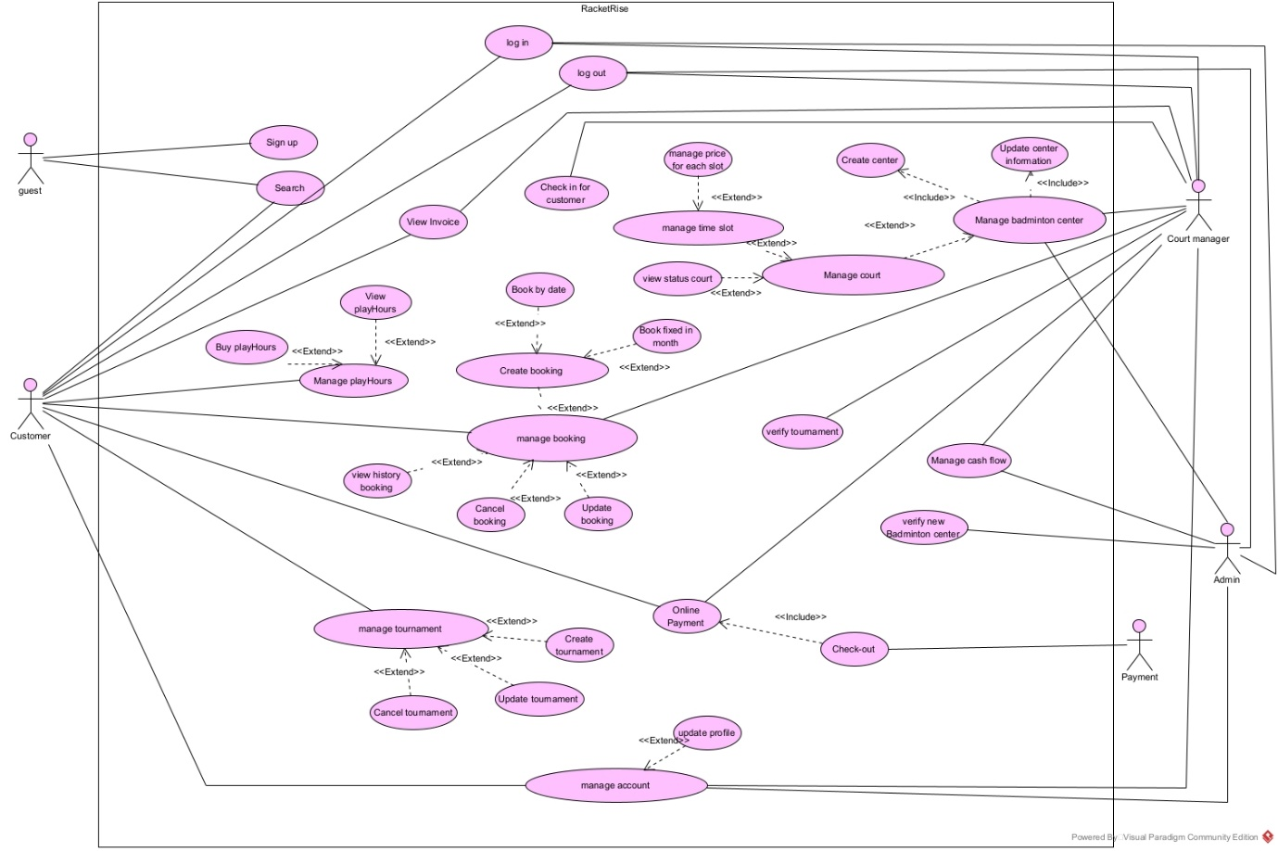

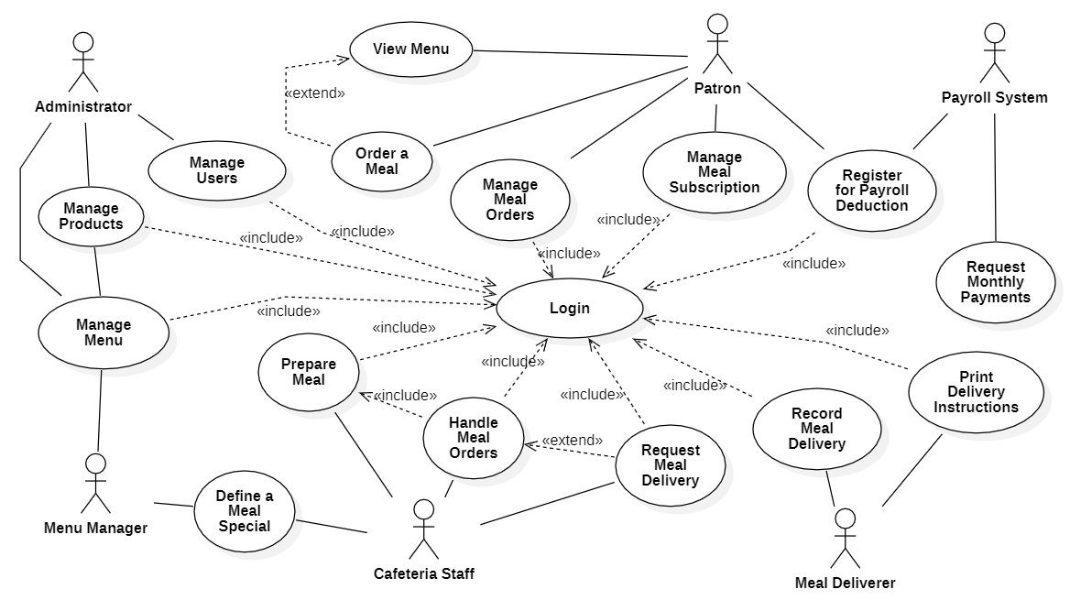

#### 2.2.2 Descriptions

*This part describes the use cases, you can follow the table form as below]*

|  |  |  |  |
| --- | --- | --- | --- |
| **ID** | **Use Case** | **Actors** | **Use Case Description** |
| 01 | |  | | --- | | Search Courts |  |  | | --- | |  | | |  | | --- | | Guest |  |  | | --- | |  | | |  | | --- | | A Guest searches for available courts based on location, operating hours, and available time slots. |  |  | | --- | |  | |
| 02 | |  | | --- | | Register Account |  |  | | --- | |  | | |  | | --- | | Guest |  |  | | --- | |  | | |  | | --- | | A Guest registers for a Customer account to gain access to booking features. |  |  | | --- | |  | |
| 03 | |  | | --- | | Book Fixed Schedule |  |  | | --- | |  | | Customer | |  | | --- | | A Customer books a recurring schedule with specific times and days each week for at least one month. |  |  | | --- | |  | |
| 04 | |  |  |  | | --- | --- | --- | | |  | | --- | | Book One-time |  |  | | --- | |  | |  |  | | --- | |  | | |  | | --- | | Customer |  |  | | --- | |  | | A Customer books a single play session at a specific time. Payment can be made online or using a purchased hour package. |
| 05 | Purchase Hour Package | |  | | --- | | Customer |  |  | | --- | |  | | A Customer purchases a package of total play hours to be used for booking one-time sessions flexibly. |
| 06 | Check-in | Customer, Court Manager | A Customer checks in upon arrival at the court, which is confirmed by the Court Manager. |
| |  | | --- | | 07 |  |  | | --- | |  | | |  | | --- | | Make Payment |  |  | | --- | |  | | Customer, Payment Gateway | A Customer makes an online payment for a court booking through the integrated payment gateway. |
| |  | | --- | | 08 |  |  | | --- | |  | | Manage Courts | Court Manager | A Court Manager registers and manages court information, schedules, and availability. |
| |  | | --- | | 09 |  |  | | --- | |  | | |  | | --- | | Manage Bookings |  |  | | --- | |  | | Court Manager | A Court Manager registers time slots for walk-in customers and manages all bookings. |
| |  | | --- | | 10 |  |  | | --- | |  | | Manage Accounts | System Admin | A System Admin manages user accounts, including Customers and Court Managers. |
| 11 | Manage System | System Admin | A System Admin oversees and manages all court information and ensures the system's integrity. |
| |  | | --- | | 12 |  |  | | --- | |  | | Update Slot Status | System Handler | The System Handler automatically updates the status of court time slots based on the current time. |

## 3. Functional Requirements

### 3.1 System Functional Overview

*[Provide functionality overview of software system: screen flow, screen descriptions, system user roles, screen authorization, non-screen functions, ERD]*

#### 3.1.1 Screens Flow

*[This part shows the system screens and the relationship among screens. You can draw the Screens Flow for the system in the form of diagram as below. Please note that beside the normal flat screen, we might have the oval notation for pop-up screen (Import Order) or a screen with multiple information tab (Order Details), etc. You may also use text or background format for different visuality purpose]*

*Customer Screen Flow*

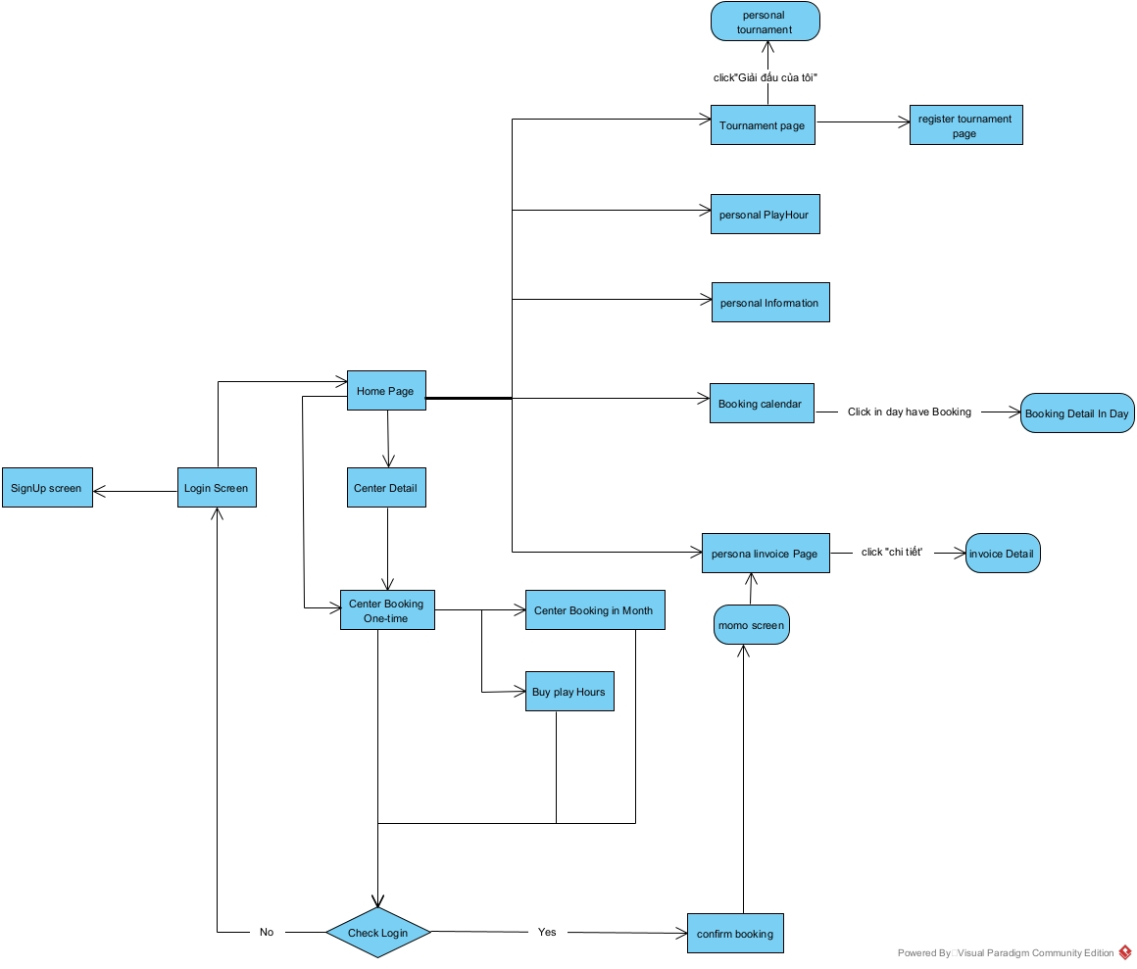

*Manager Screen Flow*

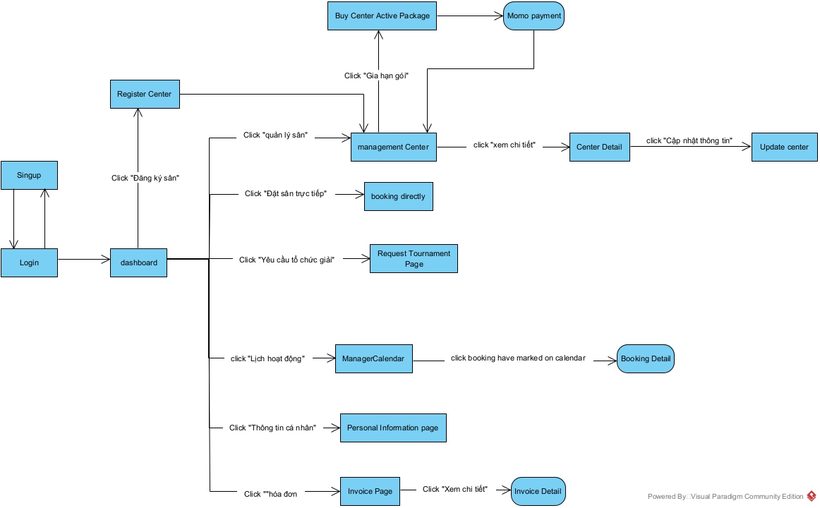

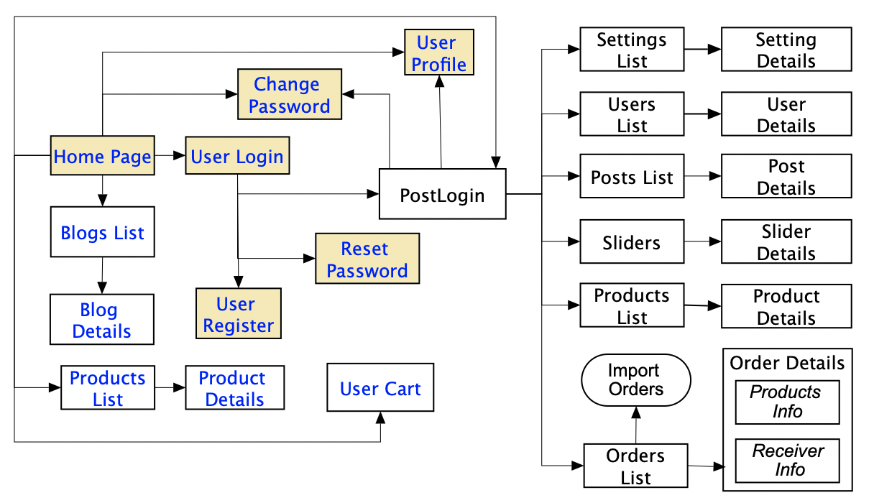

#### 3.1.2 Screen Descriptions

*[Provide the descriptions for the screens in the Screens Flow above]*

|  |  |  |  |
| --- | --- | --- | --- |
| **#** | **Feature** | **Screen** | **Description** |
| 1 | Center Search | Home Page | Screen where a Guest can search for available courts based on location, operating hours, and available time slots. |
| 2 | View center Detail | Customer Center Detail | The customer screen can view detailed information of the center |
| 3 | Account Registration | Signup | Screen where a Guest can register for a Customer account to gain access to booking features. |
| 4 | Booking One-time | Center BookingOne-time | Screen where a Customer can book a single play session at a specific time, choosing to pay online or using an hour package. |
|  |  |  |  |
| 5 | Booking Fixed Schedule | Center Book Fixed Schedule | Screen where a Customer can book a recurring schedule with specific times and days each week for at least one month. |
| 6 | Buy Hour play | Buy Play Hours | Screen where a Customer can purchase a package of total play hours to be used for booking one-time sessions flexibly. |
| 7 | Payment | Momo Screen | Screen where a Customer makes an online payment for a court booking through the integrated Momo payment gateway. |
| 8 | View Invoice | Invoice Page | Screen where Customer view their invoice and details of those invoice |
| 9 | View booking | Booking calendar | The screen where customers can visually view bookings on the calendar and view booking details |
| 10 | Manage Personal Information | Personal Information | The user screen can view personal information and change personal information, or change the password |
|  |  |  |  |
| 11 | Manager Hour play | Personal Play Hour | The screen where customers can see the total number of hours of play they have purchased at each center |
| 12 | Tournament | Tournament Page | The screen helps customers view previous tournaments of others or themselves, time, tournament center, |
| 13 | Register Tournament | Register Tournament Page | Screen where the user enters information to register the center for the tournament organization |
|  |  |  |  |
|  |  |  |  |
| 14 | Overview Center | Manager Dashboard | The screen where the manager can see an overview of the center's parameters, such as income, rate of used booking types,... |
| 15 | Validation Tournament | Request Tournament Page | The manager screen can view tournament organization requests and consider whether to accept or decline tournament organization. |
| 16 | Manage booking | Manager Calendar | The manager screen can view bookings at each court each day, and check in for customers when it's time to play |
| 17 | Manage Center | Management Center | The screen where managers can view the list of their centers |
| 18 | View Center Detail | Manager Center Detail | Screen where managers can view details of their center, displaying information such as center image, license image, price for each booking type and time frame |
|  |  |  |  |
| 19 | Update Center | Update Center | screen where managers can edit their center's information |
| 20 | Register Center | Register Center | The screen where the manager fills in the required information to create their center on the platform |
| 21 | Buy Center Package | Buy Center Active Package | The screen when the center has been approved by the admin and the manager selects the activity packages to purchase and their center will appear on the platform for customers to choose from. |
| 22 | Booking Directly | Booking Directly | The screen where managers can book directly for customers based on available slot |
| 23 | Overview Admin | Admin Dashboard | Screen where admins can view parameters such as number of subscribers, percentage of center packages purchased,... |
| 24 | Validate Center | Admin Management Center | Screen where admins can view centers and their status, as well as approve centers that meet the requirements to be able to operate on the platform |
| 25 | Manage Customer | Manage Customer | Screen where admin can view customer information except password |
|  |  |  |  |
| 26 | Manage Manager | Manage Manager | Screen where admin can view manager information except password |
|  |  |  |  |
| 27 | Login | Login | screen that users use to log in to the platform using email and password |
|  |  |  |  |
|  |  |  |  |
|  |  |  |  |

3.1.3 Screen Authorization

|  |  |  |  |  |  |  |
| --- | --- | --- | --- | --- | --- | --- |
| **Screen** | Guest | Customer | Manager | | Admin | | --- |  |  | | --- | |  | |
| |  | | --- | | Home Page |  |  | | --- | |  | | X |  |  |  |
| Signup | X | X | X |  |
| Login | X | X | X | X |
| Customer Center Detail | X | X |  |  |
| Center Booking One-time | X | X |  |  |
| Center Book Fixed Schedule | X | X |  |  |
| Buy Play Hours | X | X |  |  |
| Momo Screen |  | X | X |  |
| Invoice Page |  | X | X |  |
| Booking Calendar |  | X |  |  |
| Personal Information |  | X | X | X |
| Personal Play Hour |  | X |  |  |
| Tournament Page | X | X |  |  |
| Register Tournament Page | X | X |  |  |
| Manager Dashboard |  |  | X |  |
| Request Tournament Page |  |  | X |  |
| Manager Calendar |  |  | X |  |
| Management Center |  |  | X |  |
| Manager Center Detail |  |  | X |  |
| Update Center |  |  | X |  |
| Register Center |  |  | X |  |
| Buy Center Active Package |  |  | X |  |
| Booking Directly |  |  | X |  |
| Admin Dashboard |  |  |  | X |
| Admin Management Center |  |  |  | X |
| Manage Customer |  |  |  | X |
| Manage Manager |  |  |  | X |
|  |  |  |  |  |
|  |  |  |  |  |

#### 3.1.4 Non-Screen Functions

*[Provide the descriptions for the non-screen system functions, i.e batch/cron job, service, API, etc.]*

|  |  |  |  |
| --- | --- | --- | --- |
| **#** | **Feature** | **System Function** | **Description** |
| 1 | <<Feature Name>> | <<Function Name1>> | <<Function Name1 Description>> |
| 2 | … |  |  |

#### 3.1.5 Entity Relationship Diagram

*[Provide the ntity relationship diagram and the entity descriptions in the table format as below]*

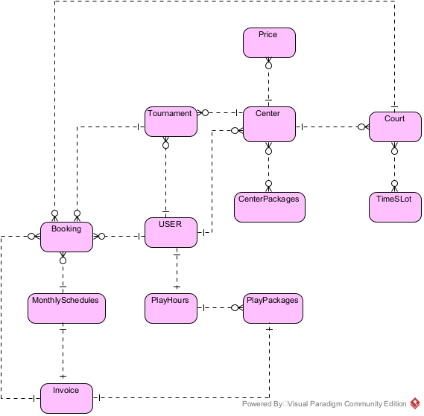

**Entities Description**

|  |  |  |
| --- | --- | --- |
| **#** | **Entity** | **Description** |
| 1 | User | Store user information including email, password, phone number,... |
| 2 | Center | Stores Center information created by manager |
| 3 | Center Package | Storing information about activity packages, the center will select packages to extend operating time on the platform |
| 4 | Court | Store information about the court in a center |
| 5 | TimeSlot | Store information and status of slots for each day of each court |
| 6 | Price | Store information about the price of each booking type and the Center's time frame |
| 7 | Tournament | Stores information about tournaments created by customers |
| 8 | Booking | Store booking information and status according to each date and time frame set by the customer |
| 9 | Monthly Schedules | Stores information about fixed booking schedules in the month that the customer booked |
| 10 | Play Hours | Store information about the number of playing hours a customer has in a center |
| 11 | Play Packages | Store information about the number of hours played and the price spent by the customer |
| 12 | Invoice | Store information about prices of transaction types in the system |
|  |  |  |
|  |  |  |
|  |  |  |

### 3.2

3.2.1 Create Account

#### 3.2.1.1 Signup

Function trigger: Guest sends requests to create an account with a customer role in the system by filling all required fields and clicking the “Đăng ký” button.

Function description: This feature allows the Guest to create a new account in the User System

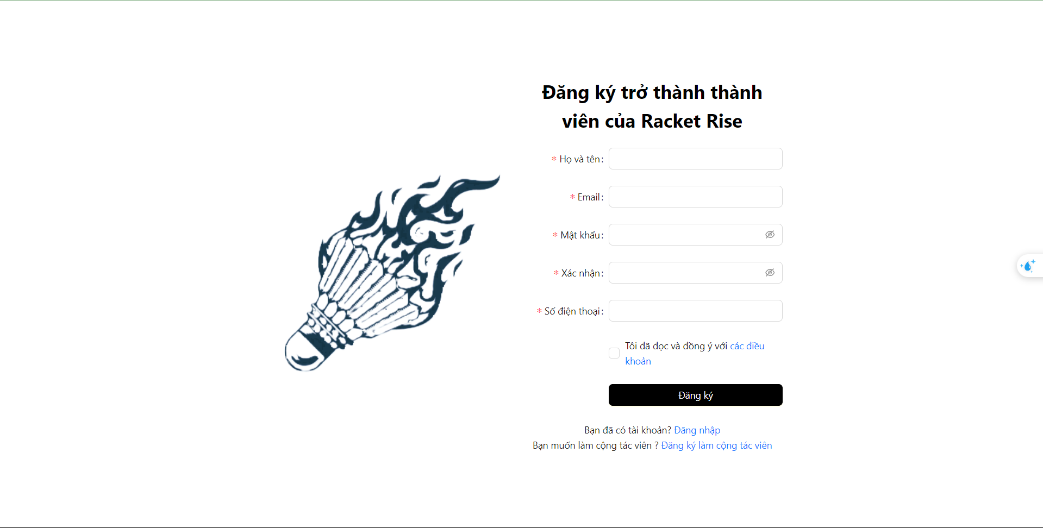

Function details:

* Pre-condition: guest does not have any accounts in the RacketRise system yet.
* Flow:
  + Guest inputs all required fields and clicks on the “Đăng ký”
  + System verifies and creates the new account based on the information that is provided by the Guest
  + System automatically redirects the user to the Login Page
* Data inputs:
  + Họ và tên: required
  + Email: email format, required.
  + Mật khẩu: required
  + Xác nhận: must be the same as “Mật khẩu field”, required.
  + Số điện thoại: Phone format, required.
* System validates the new account’s information:
  + Success: The system creates a new account based on the information provided. Redirect users to the login page.
  + Fail: System shows an error message based on the actor’s actions.
* Business Rules:
  + Email must be unique in the system.

#### 3.2.1.2 Signup Manager

Activation function: Customers submit a request to create an account as a manager in the system by filling in all required fields and pressing the "Register" button.

Function description: This feature allows Customers to create new accounts in the manager center system

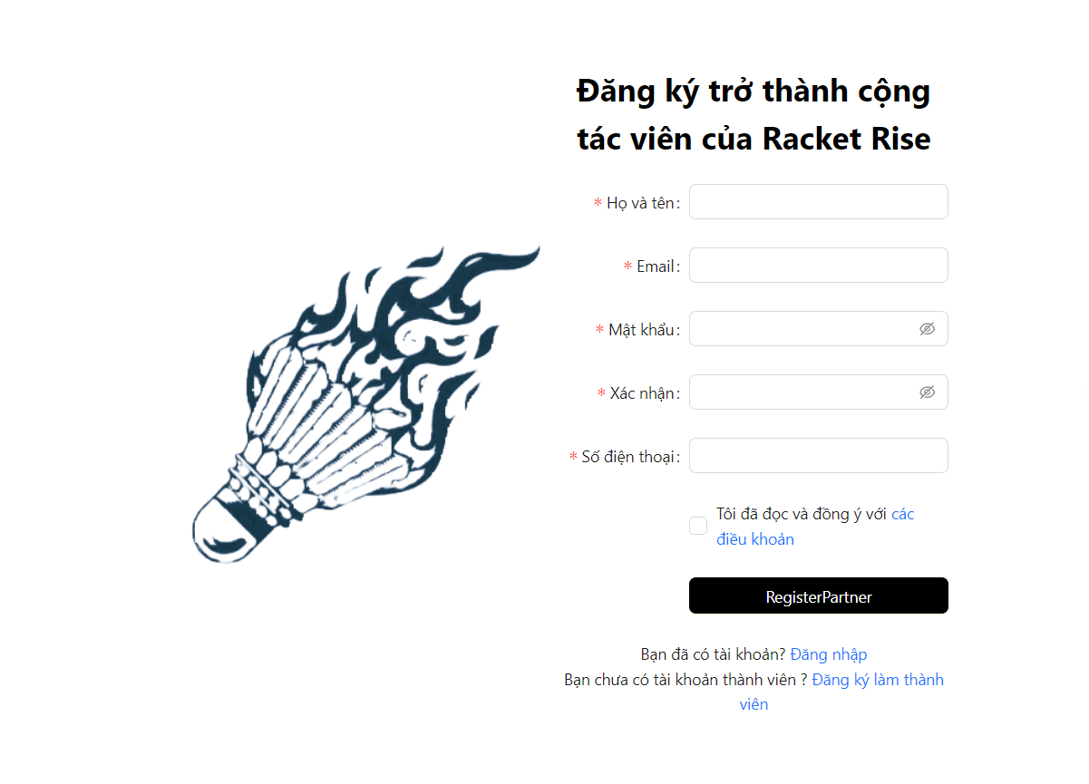

Function details:

* Pre-condition: guest does not have any accounts in the RacketRise system yet.
* Flow:
  + Guest inputs all required fields and clicks on the “Đăng ký” button
  + System verifies and creates the new account based on the information that is provided by the Guest
  + System automatically redirects the user to the Login Page
* Data inputs:
  + Họ và tên: required
  + Email: email format, required.
  + Mật khẩu: required
  + Xác nhận: must be the same as “Mật khẩu field”, required.
  + Số điện thoại: Phone format, required.
* System validates the new account’s information:
  + Success: The system creates a new account based on the information provided. Redirect users to the login page.
  + Fail: System shows an error message based on the actor’s actions.
* Business Rules:
  + Email must be unique in the system.

3.3.2 Authenticate

*3.3.2.1 Log In*Function trigger: Member requests login into the system by filling in the email and password and tapping on the “Đăng nhập” button.

Function description: This feature allows Members to log in to the User System as a Customer or manager or administrator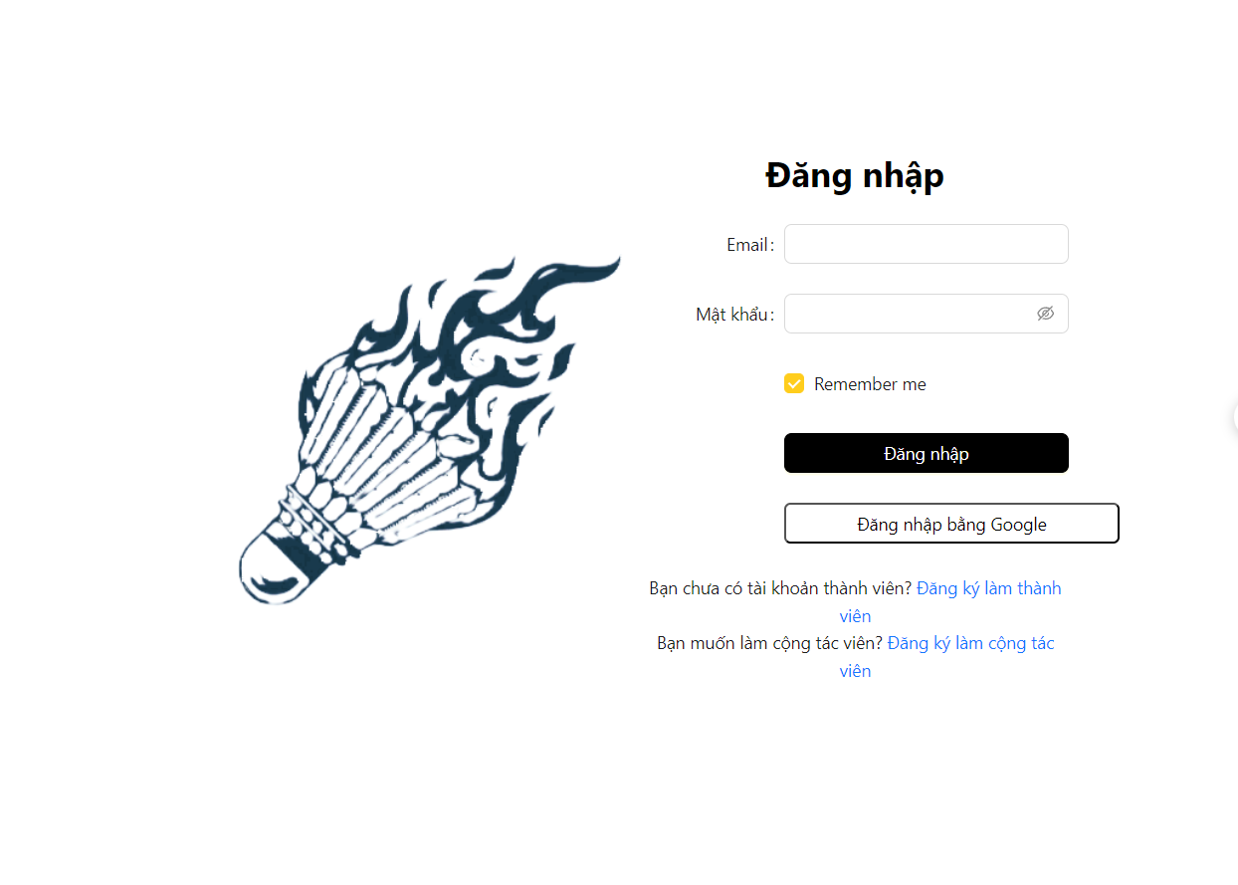

Function details:

* Pre-condition:
  + Member already have an account in the User System.
* Flow:
  + Member fill in the email and password and click on the “Đăng nhập” button to send the request to login into the system.
  + System after the validation step will automatically redirect the user to the home page or dashboard if their role is manager or admin
* Data inputs:
  + Email: email format, required.
  + Mật khẩu: required
* System validates the account’s information:
  + Success: System displays the successful message and redirects the user to the home page..
  + Fail: System shows an error message based on the actor’s actions.

3.3.3 Center Search

*3.3.3.1 View List Center*

Function trigger: Customer views the desired location or course name or time frame and presses the magnifying glass button

Function description: This function allows customers or guests to view the list of active centers and search based on needs

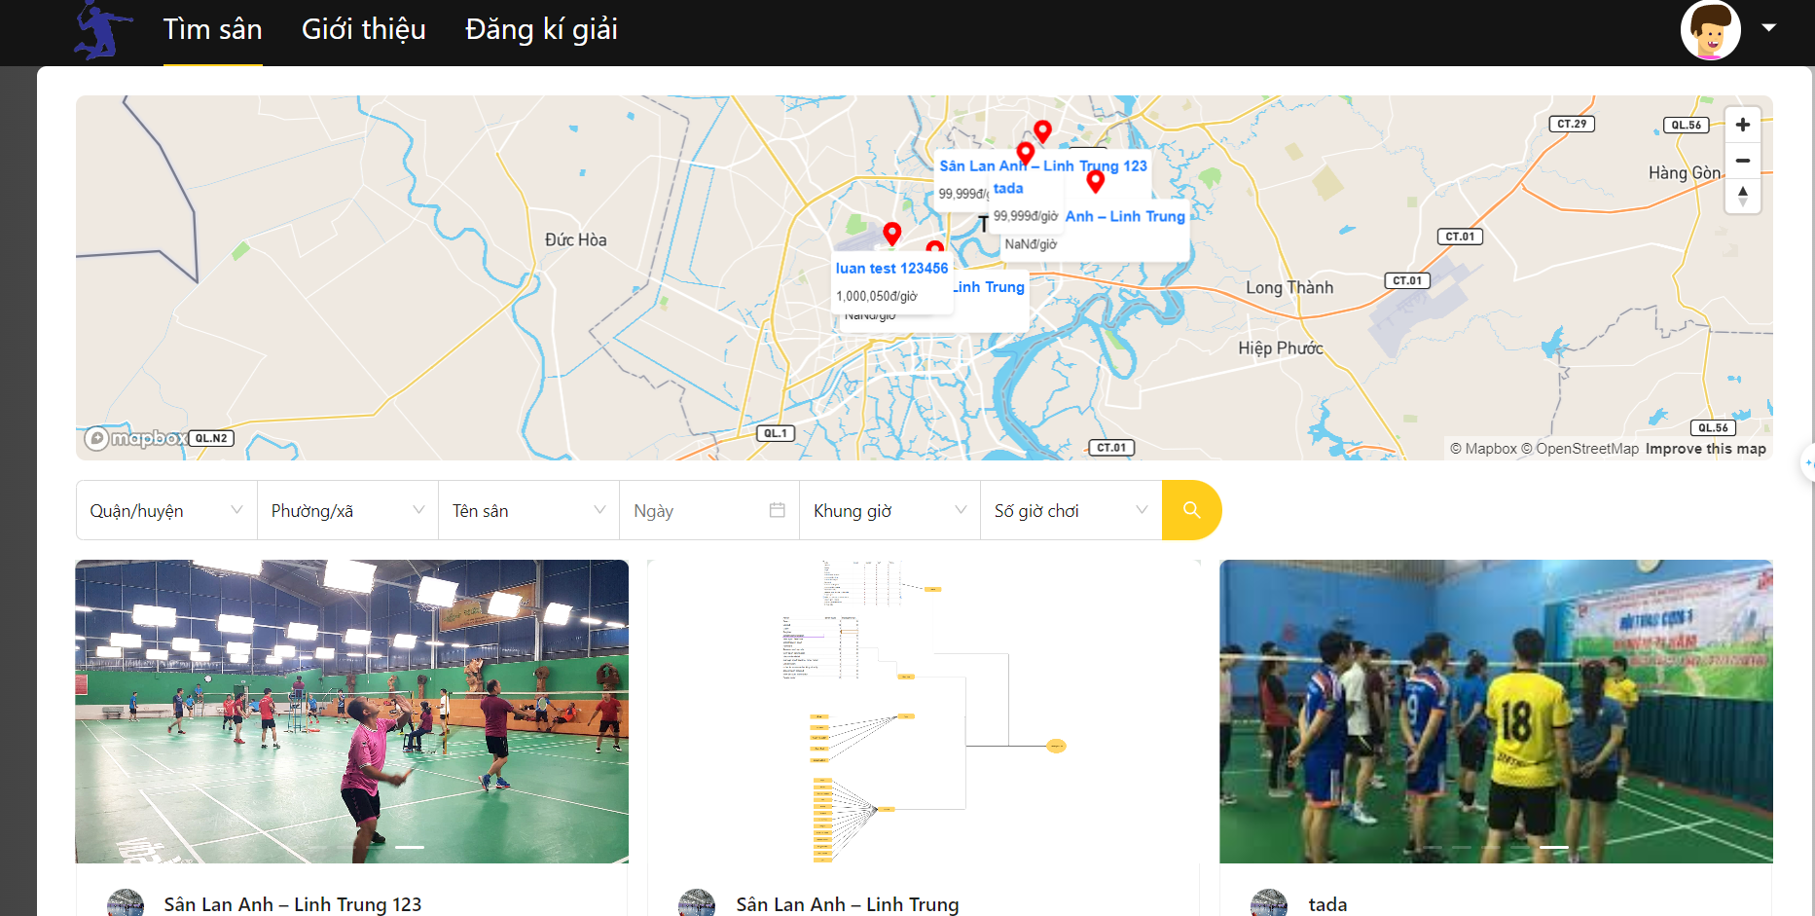

Function details:

* Flow:
  + Users view the list of courses and when they want to find a course, select and fill in the information they need to find
  + The system receives user information and filters out centers according to user needs

3.3.4 View Center Detail

*3.3.4.1 Customer Center Detail*

3.3.5 Booking

*3.3.5.1 Booking Once time*

Function trigger: The user selects the desired date, time frame and duration than selects court available

Function description: This function allows users to select and Book court in a center according to the desired time

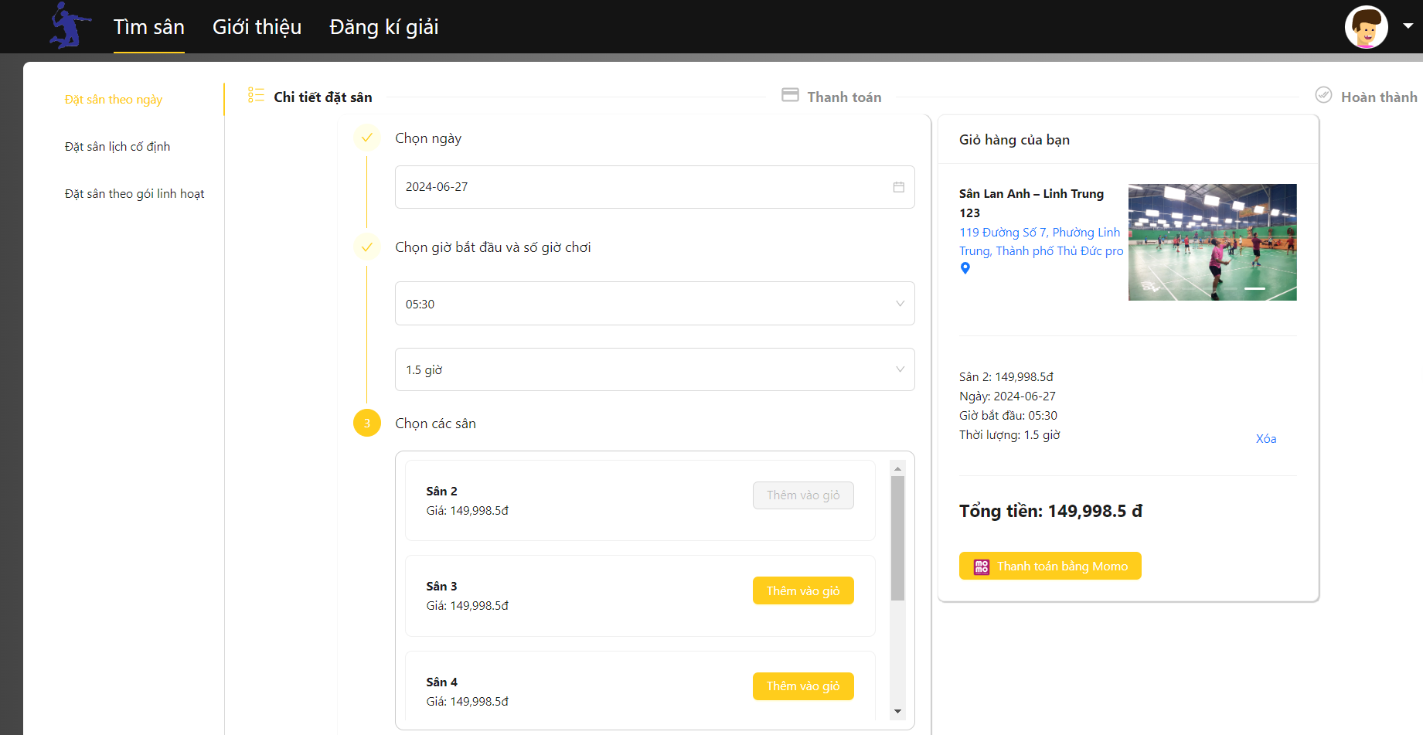

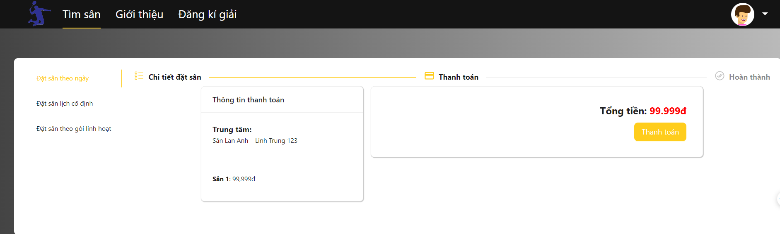

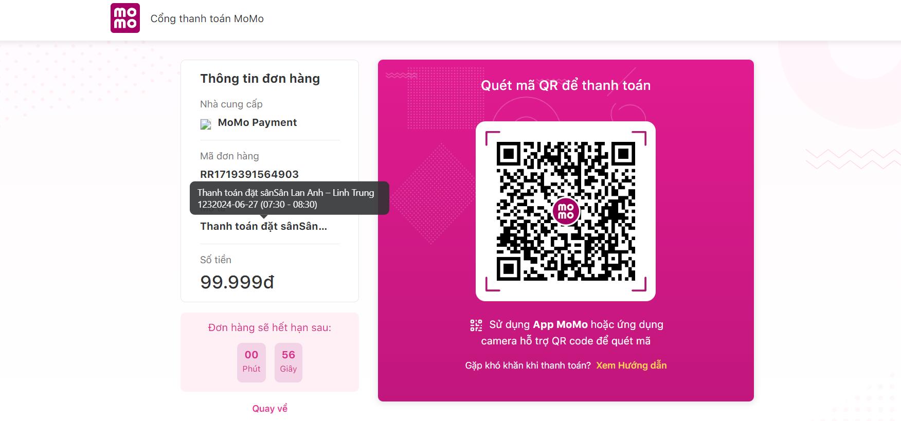

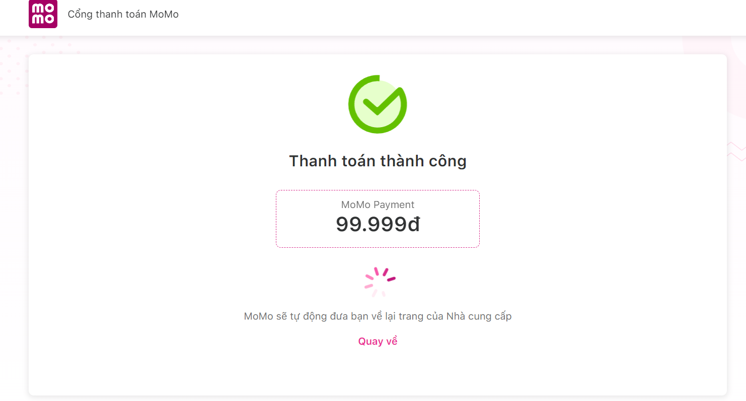

Function details:

* Pre-condition: Just customer can booking court .
* Flow:
  + Customer choose Date they want
  + System filter the Start time available
  + Customer choose the start time
  + System filter the duration available
  + Customer choose the duration
  + System filter the court available
  + Customer select the court by pressing the " Thêm vào giỏ" button
  + System calculate total money for all court customer have select
  + Customer pressing the “Thanh toán bằng momo” button
  + Customer View the total money and press “Thanh toán” button
  + System redirect to momo payment gateway.
  + Customer scan QR code and pay money.
* System validates payment status:
  + Success: The system announces success and redirects users to the Invoice page.
  + Fail: The system reports failure and redirects to the home page
* Business Rules:
  + Only users with the customer role can perform this booking function.
  + Can only be booked within the latest 7 days from the current date.

3.3.5.1 Booking *Fixed Schedule*

Function trigger: Customer selects court, start date and number of months. Choose the day of the week, start time and number of hours to play. and press the “tính giá” button

Function description: The function allows Customers to book at fixed times of the week in 1 booking.

Function details:

* Pre-condition: Just customer can booking Fixed Schedule.
* Flow:
  + Customer choose Court
  + Customer choose Start Date
  + Customer chooses the number of months
  + Customer selects the day of the week
  + The system will filter available start times
  + Customer select start time
  + The system will filter available duration
  + Customer choose duration.
  + Customer presses the "Tính giá" button and makes payment
* System validates payment status:
  + Success: The system announces success and redirects users to the Invoice page.
  + Fail: The system reports failure and redirects to the home page
* Business Rules:
  + Only users with the customer role can perform this booking function.
  + Can only select a start date after 7 days from the current date
  + Each day of the week can only choose 1 start time and duration

3.3.6 Play Hour

3.3.6.1 Buy Play Hour

Function trigger: Customers choose the number of playing hours they want to buy from the center and press the “Chọn gói” button to make payment

Function description: The function allows customers to buy hours of play at a center so that they can book one time equal to the number of hours of play that the customer owns at a center.

Function details:

* Pre-condition: Just customer can Buy Play Hour.
* Flow:
  + Customer select numbers of hour they want to buy
  + Click “chọn gói” button to make payment
* System validates payment status:
  + Success: The system announces success and redirects users to the Invoice page.
  + Fail: The system reports failure and redirects to the home page
* Business Rules:
  + Only users with the customer role can perform this Buy Play Hour function.
  + Can only be purchased for hours over 10 hours

3.3.7 Invoice

*3.3.7.1 View Invoice*

Function description: Users can view the invoices they have used.

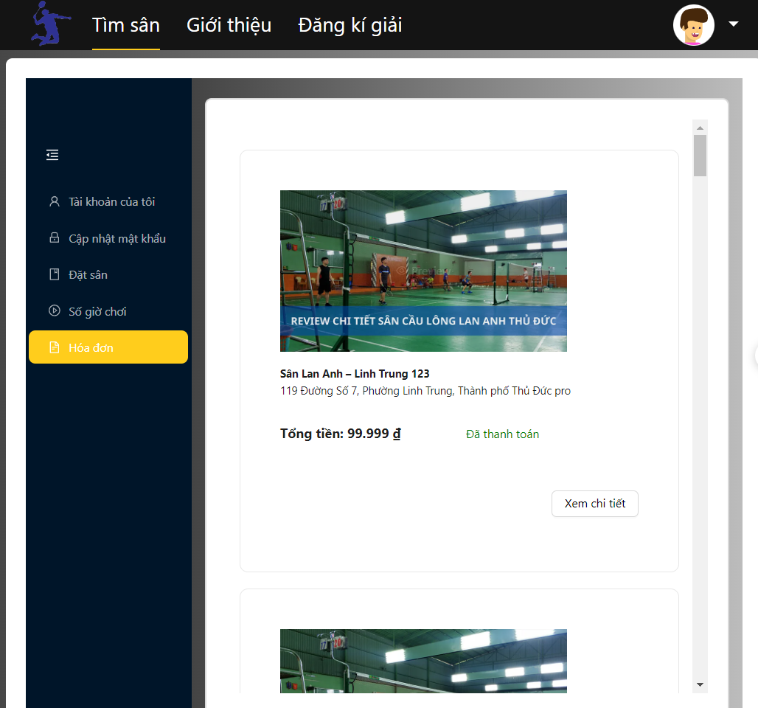

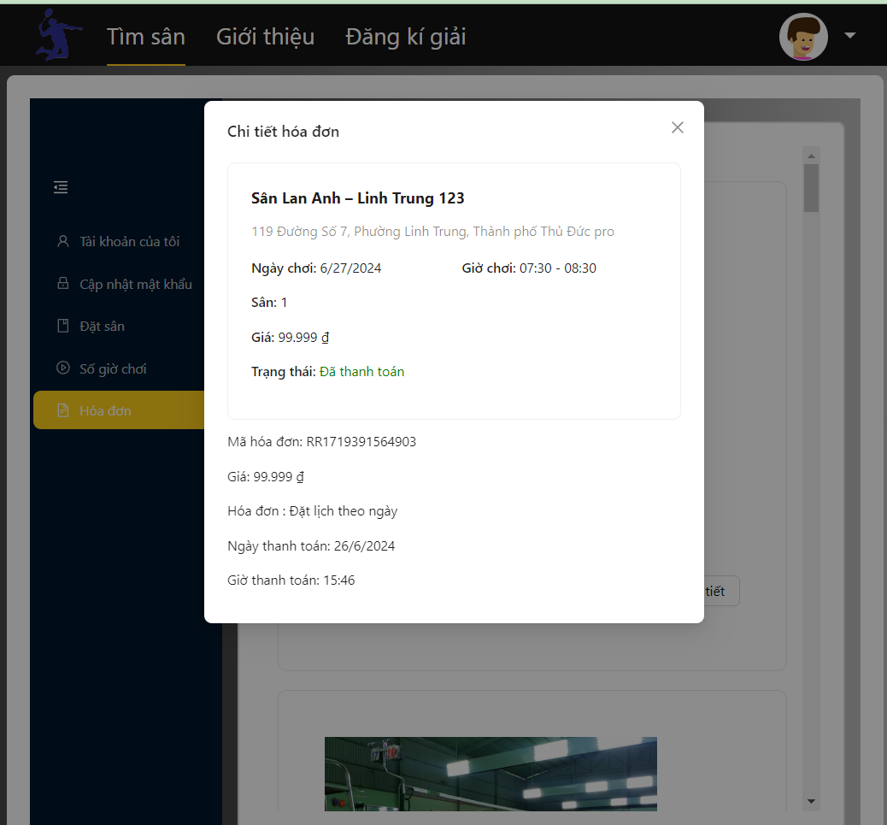

Function details:

* Pre-condition: Just customer and manager can view their invoice.
* Flow:
  + Click “Xem chi tiết” to view Invoice Detail

3.3.8 Manage Booking

*3.3.8.1 View Booking in Calendar*

Function description: Customers can view booked dates and mark them on the calendar, view booking details

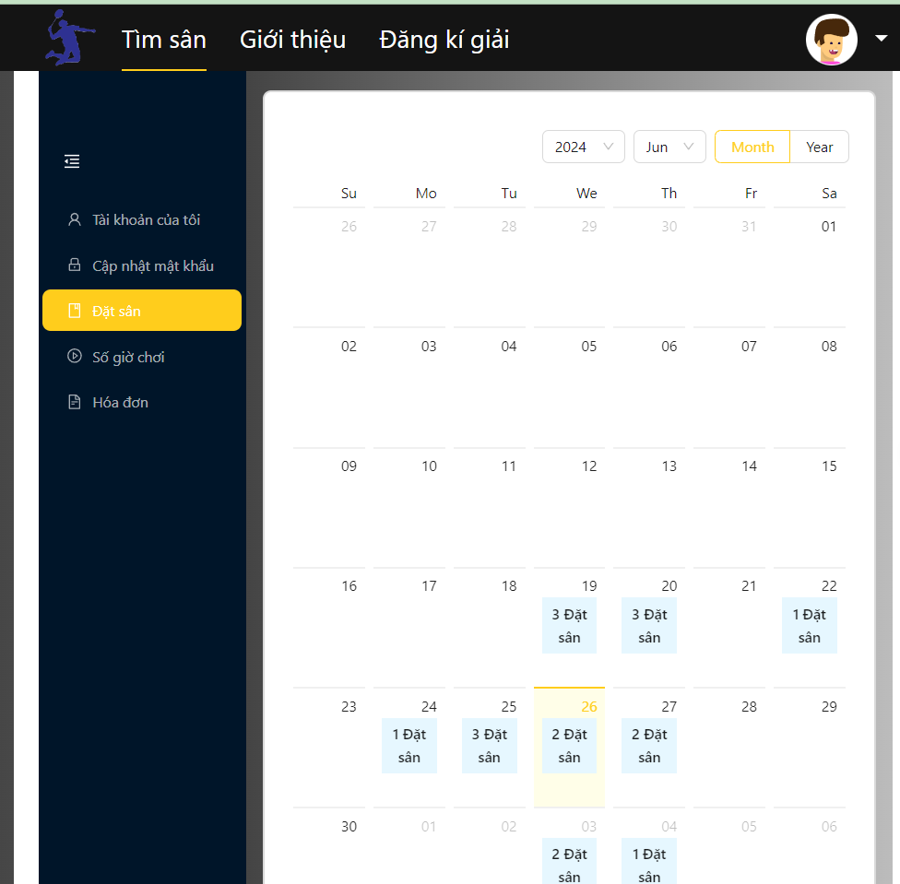

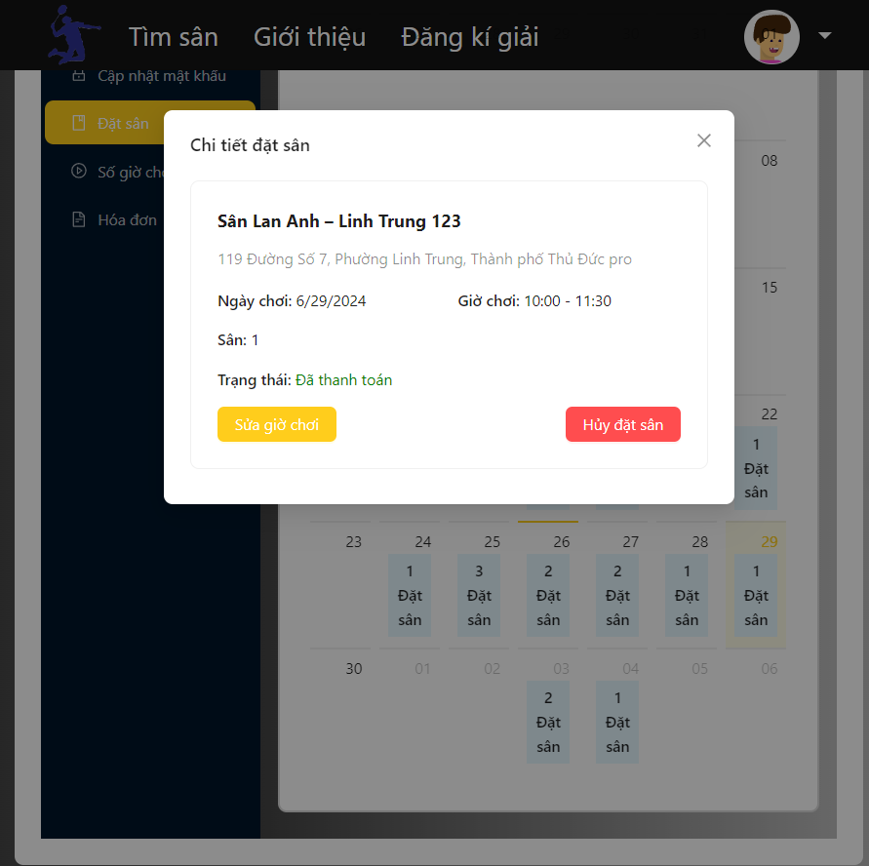

Function details:

* Pre-condition: Just customer and manager can view their Booking.
* Flow:
  + Click on the highlighted date to view booking details

*3.3.8.2 Change booking*

Function trigger: Customer selects a new playing time frame and presses the "Xác nhận" button to make payment

Function description: The function allows customers to change booking hours and pay the difference.

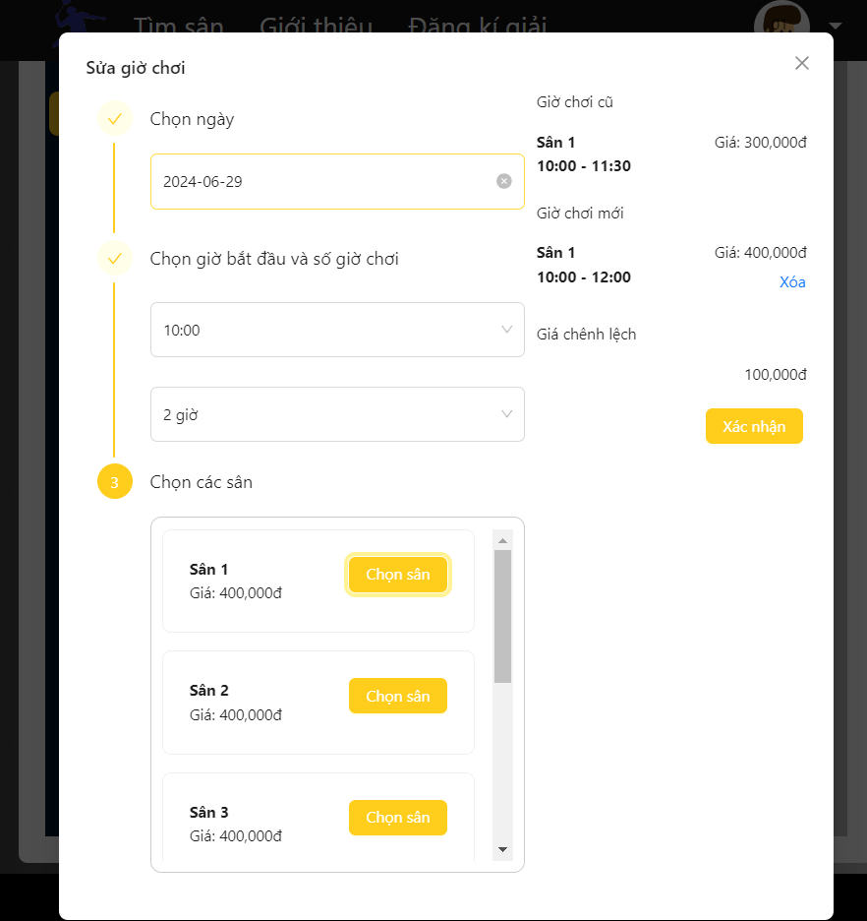

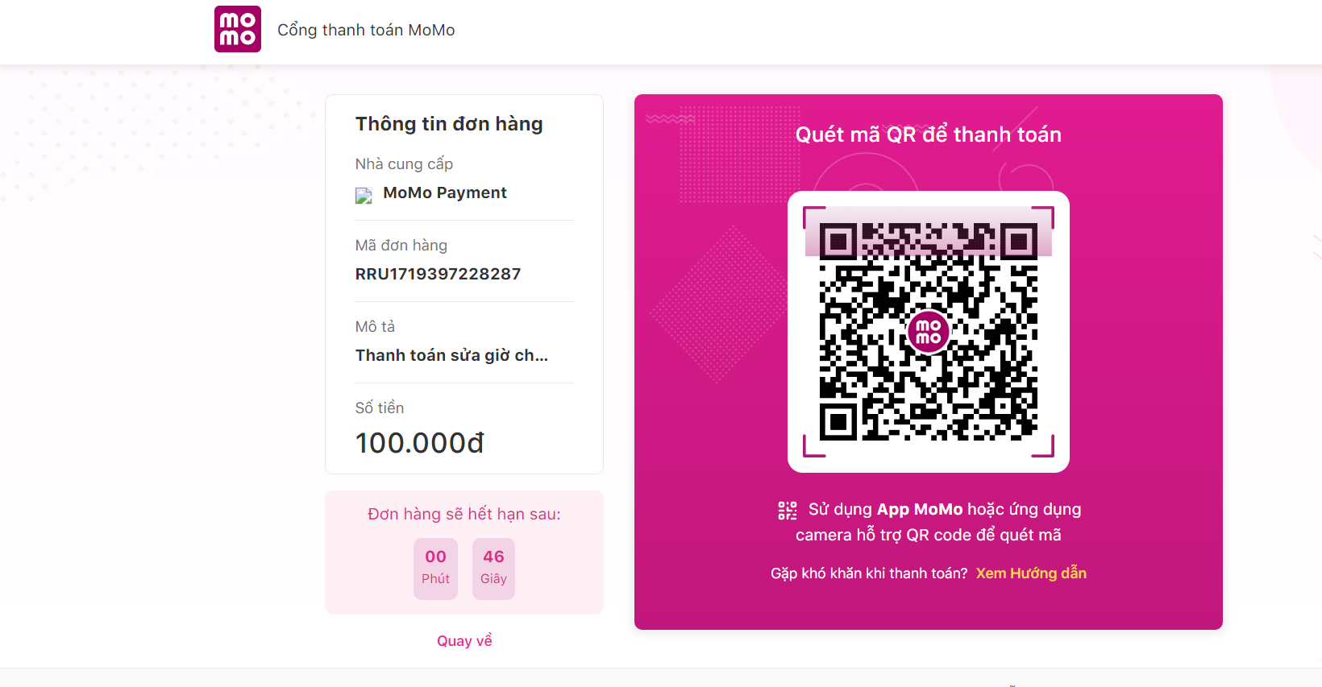

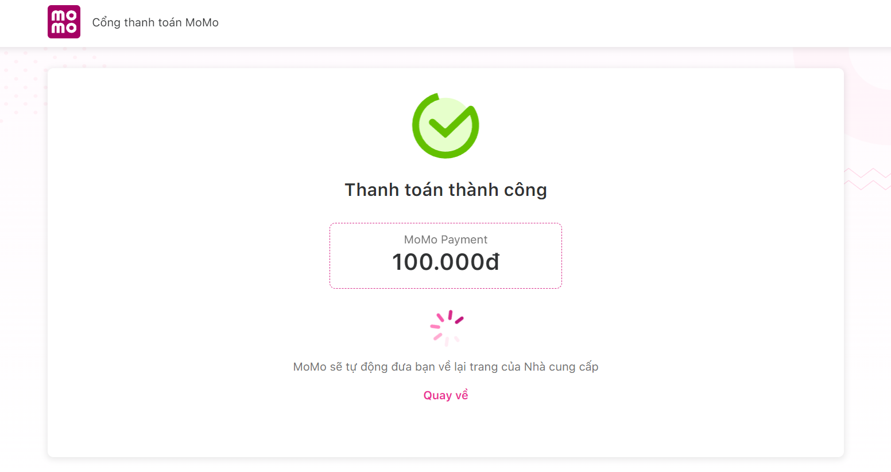

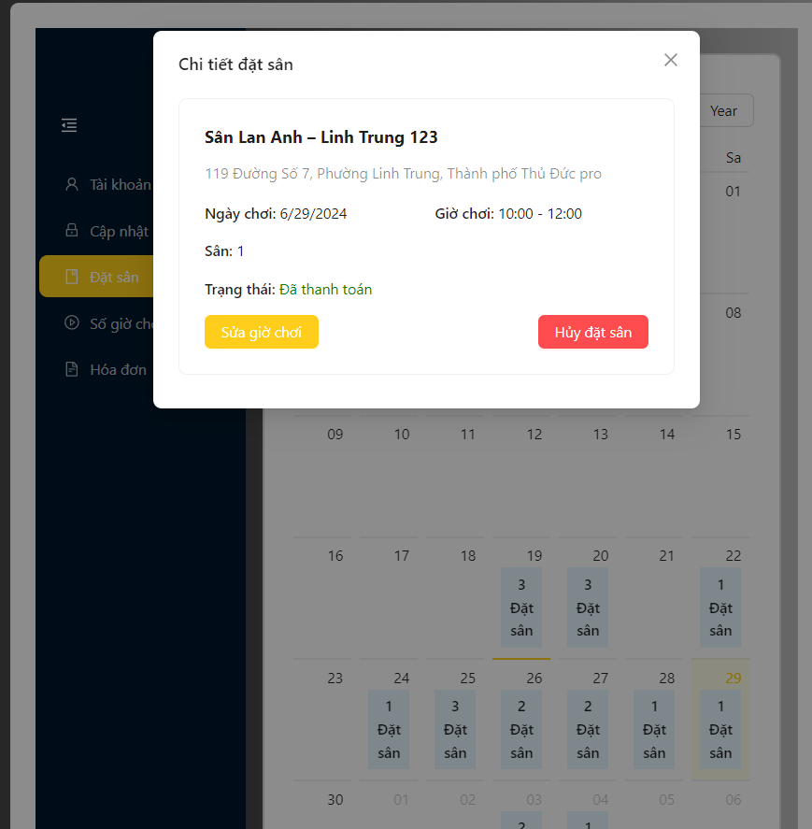

Function details:

* Pre-condition: Just customer can change their personal booking.
* Flow:
  + Customer choose Date they want
  + System filter the Start time available
  + Customer choose the start time
  + System filter the duration available
  + Customer choose the duration
  + System filter the court available
  + Customer select the court by pressing the " Chọn sân" button
  + The system calculates the total amount for the difference between the 2 old and new courts the customer has chosen
  + Customer pressing the “Xác nhận” button
  + System redirect to Momo payment gateway.
  + Customer scan QR code and pay money.
* System validates payment status:
  + Success: The system announces success and redirects users to booking calendar page.
  + Fail: The system reports failure and redirects to the booking calendar page.
* Business Rules:
  + Only users with the customer role can perform this change booking function.
  + If the difference is negative, the Customer will not receive the difference back.

*3.3.8.2 Cancel booking*

Function trigger: Customers press the "Hủy đặt sân" button to cancel booking

Function description: Function that allows Customers to cancel reservations.

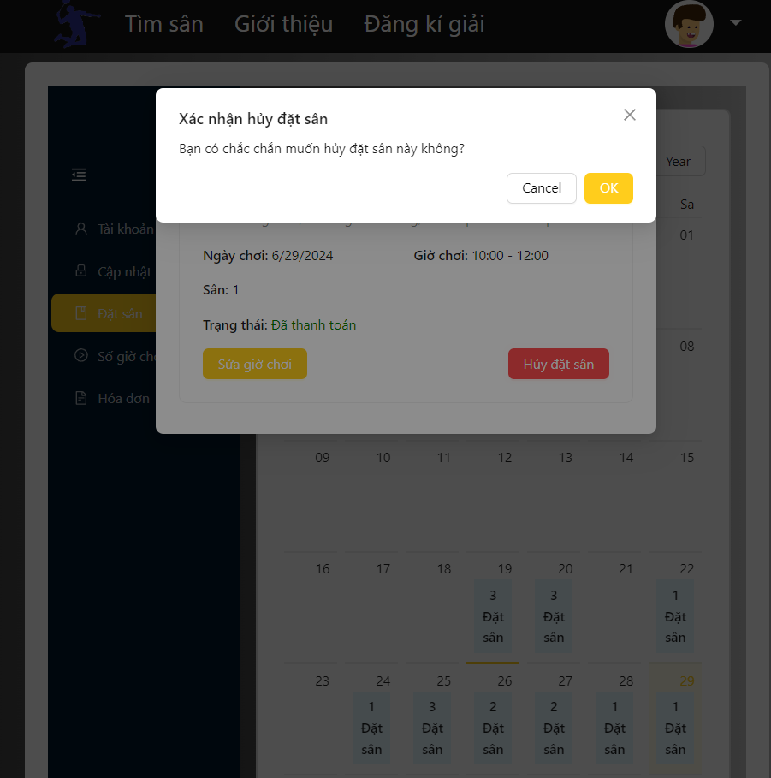

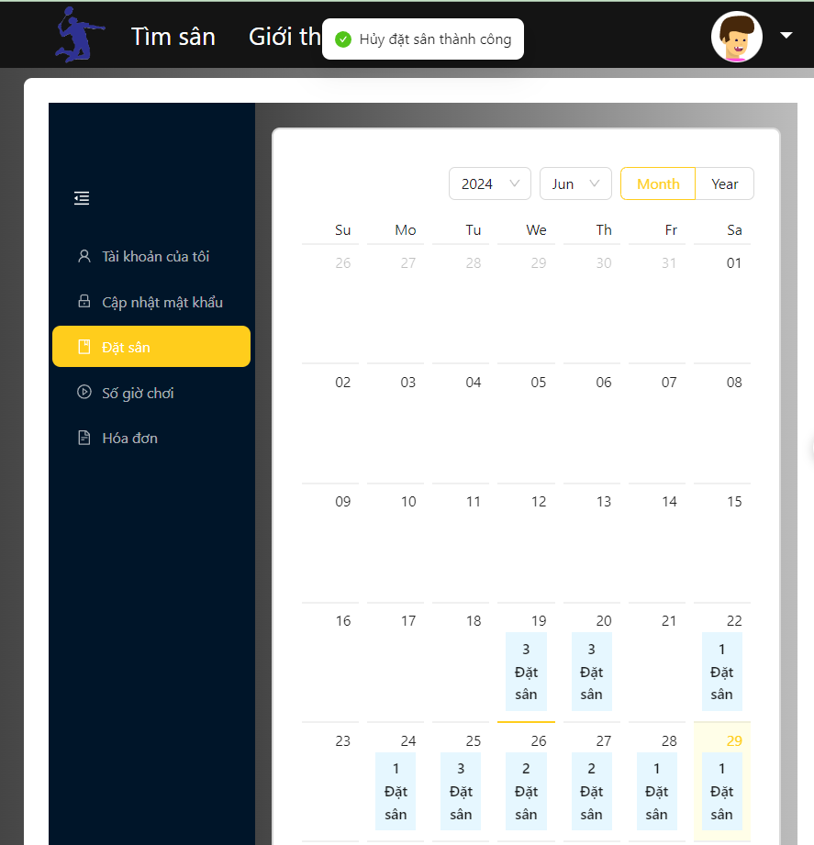

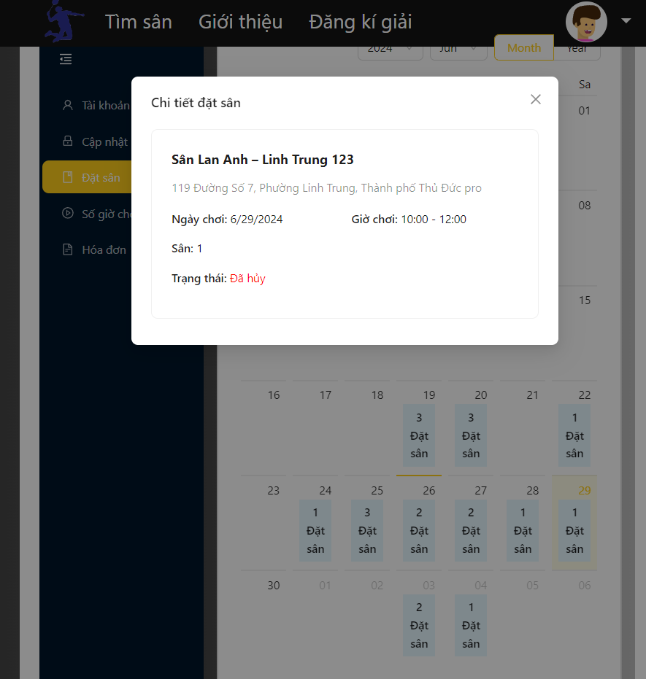

Function details:

* Pre-condition: Just customer can cancel their personal booking.
* Flow:
  + Customer press “Hủy đặt sân” button.
  + Customer press “ok” button in confirm form
  + System change booking status to cancle
* System validates cancel status:
  + Success: The system announces success and redirects users to booking calendar page.
  + Fail: The system reports failure and redirects to the booking calendar page.
* Business Rules:
  + Only users with the customer role can perform this cancel booking function.
  + If the time customer want to cancel is within the same day, it is not possible

3.3.9 Manage Personal Information

*3.3.9.1 Change personal Information*

Function trigger: user sends requests to update an account in the system by filling all required fields and clicking the “Cập nhật tài khoản” button.

Function description: Function that allows Customers to update Information.

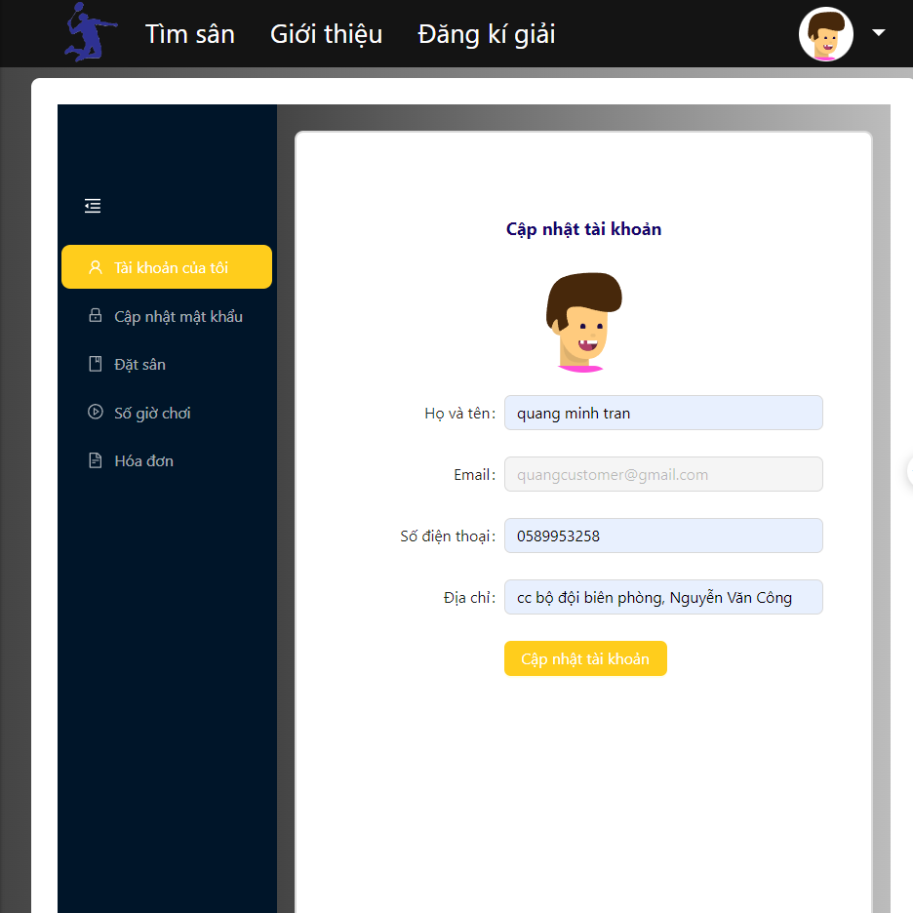

Function details:

* Pre-condition: Just customer can update their personal Information.
* Flow:
  + Customer inputs all required fields and clicks on the “Cập nhật tài khoản”button.
* System validates cancel status:
  + Success: The system announces success and redirects users Personal information page.
  + Fail: The system reports failure and redirects to Personal information page.

*3.3.9.2 Change personal Password*

Function trigger: user sends requests to update password by filling all required fields and clicking the “Cập nhật mật khẩu” button.

Function description: Function that allows Customers to update password.

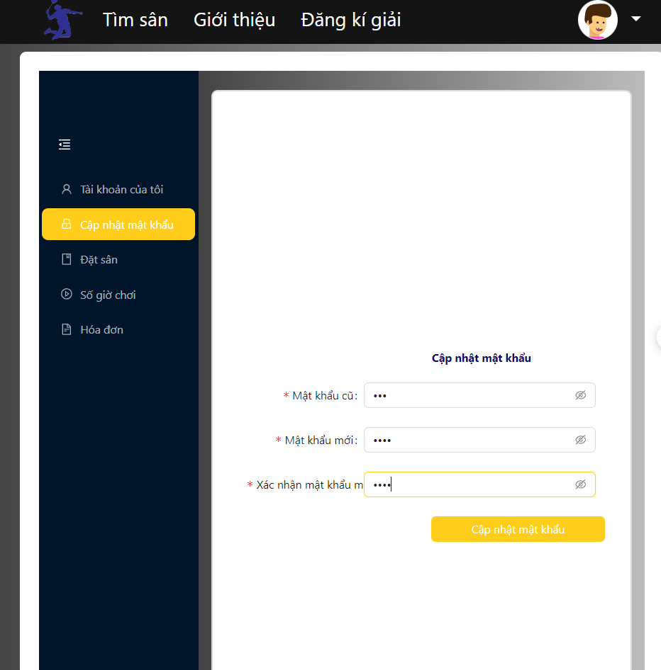

Function details:

* Pre-condition: Just authenticate user can update their password.
* Flow:
  + Customer inputs all required fields and clicks on the “Cập nhật mật khẩu”button.
* System validates cancel status:
  + Success: The system announces success and redirects users Personal password page.
  + Fail: The system reports failure and redirects to the Personal password page.

3.3.10 Tournament

*3.3.10.1 View Tournament*

Function description: Function that allows Customers to view previous tournament.

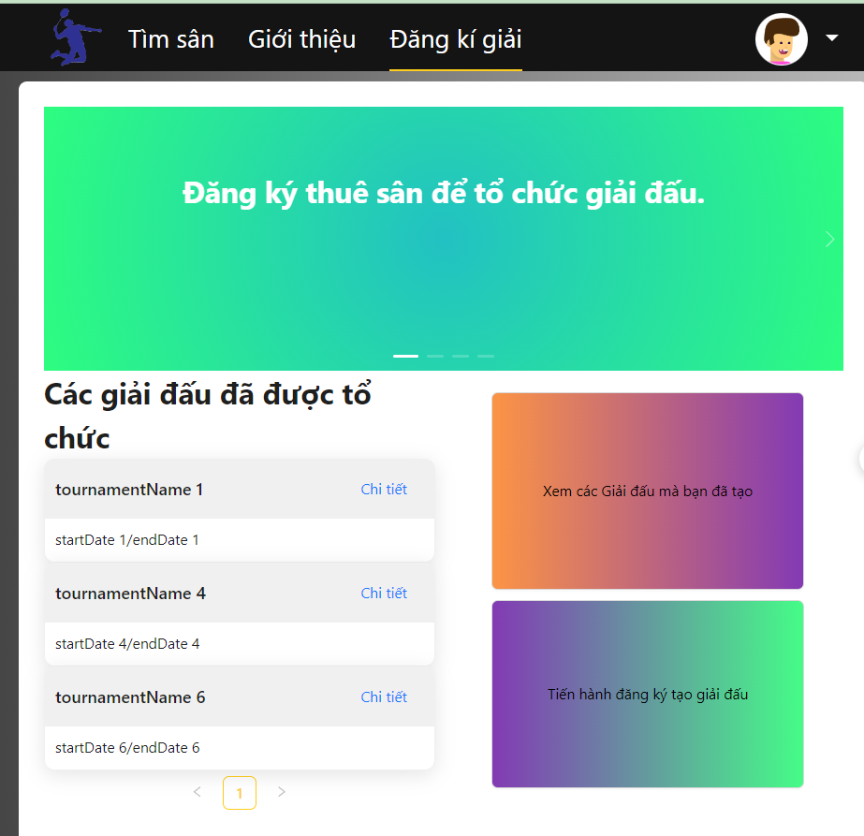

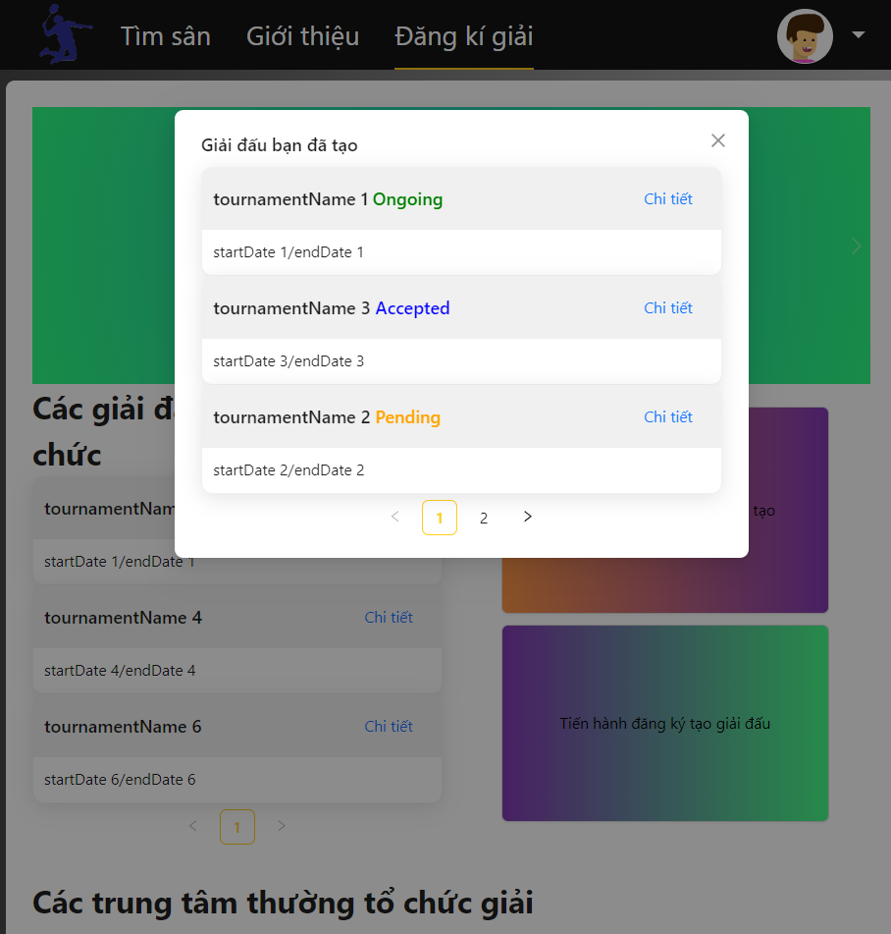

*3.3.10.2 Register Tournament*

Function trigger: Customer submits a request to rent a center to host a tournament by filling in all required fields and clicking the “Đăng ký” button.

Function description: The function allows customers to register to organize tournaments at a center

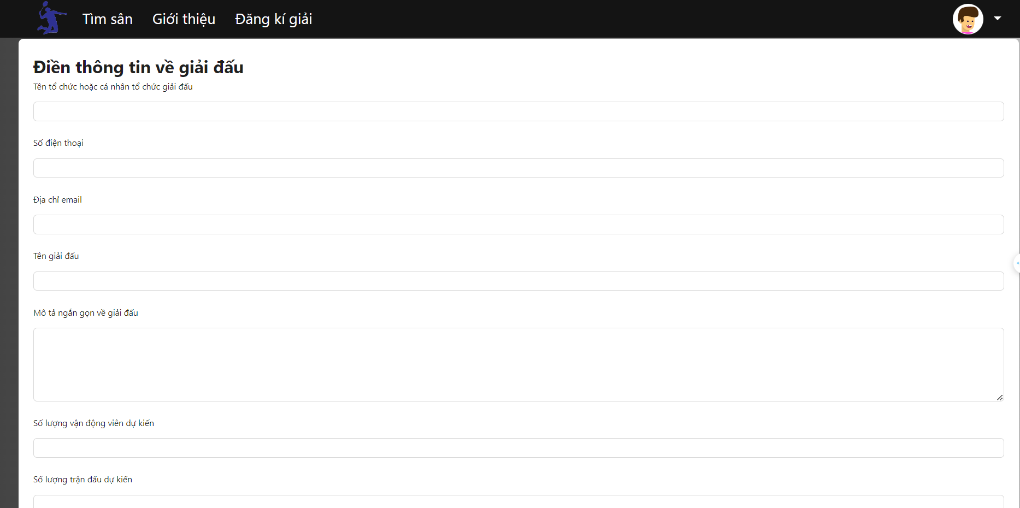

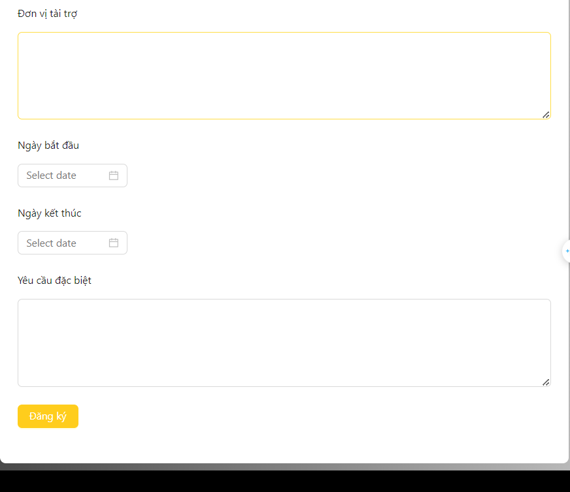

Function details:

* Pre-condition: Just customer can register tournament.
* Flow:
  + Customer fills in all required fields.
  + Customer press “Đăng ký” button in confirm form
  + The system creates a tournament according to the information and sends it to the registered center manager.
* Business Rules:
  + Only users with the customer role can perform this register tournament function.
  + Must register for tournament at least 7 days in advance.

3.3.11 Manager Overview

*3.3.11.1 Manager Dashboard*

Function description: The function allows managers to view center information such as total number of bookings, revenue and percentage of booking types.

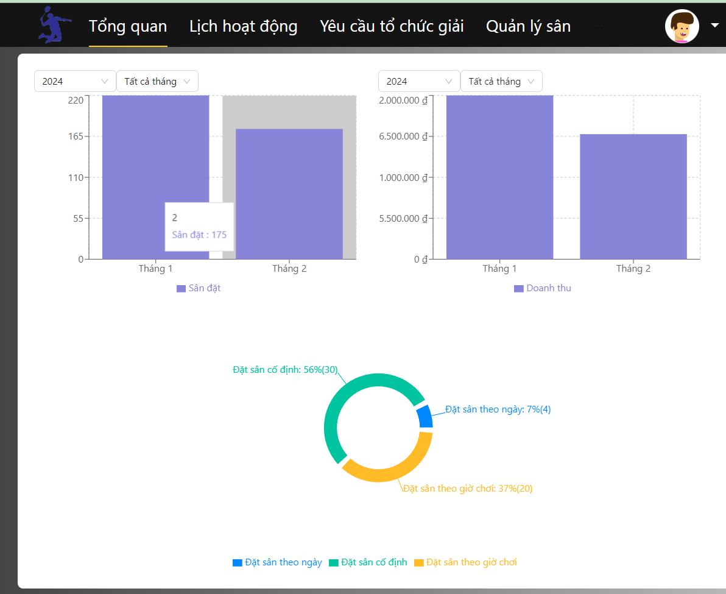

3.3.12 Manage booking

*3.3.12.1 Manager Calendar*

Function trigger: Select the booking marked on the court to see the booking detail

Function description: Manager can view bookings at courts during the day and check in for guests when the time comes

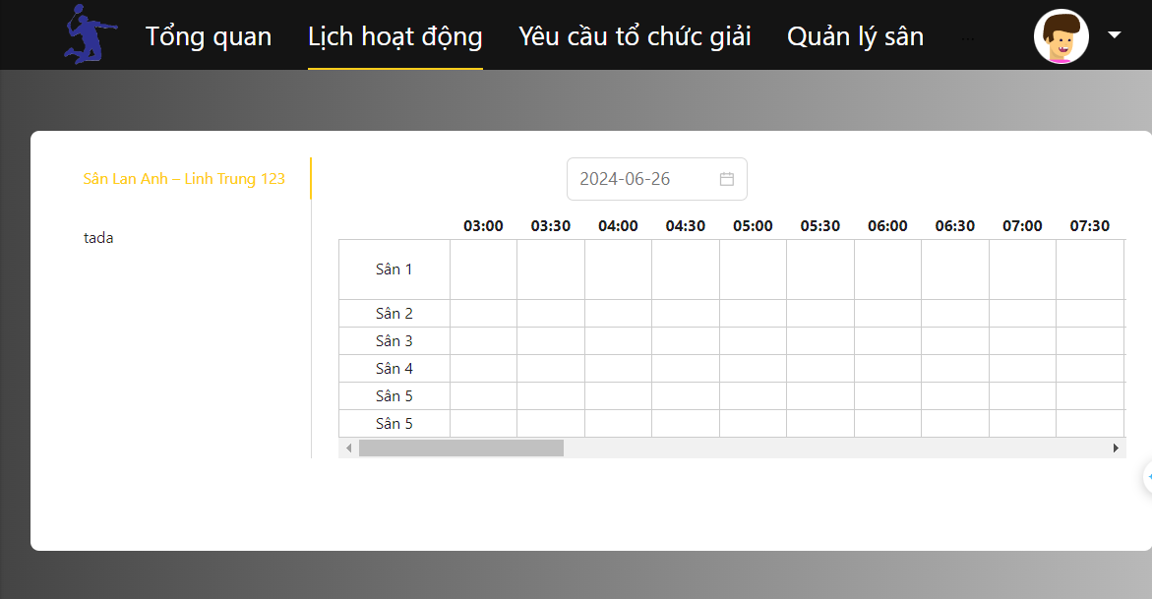 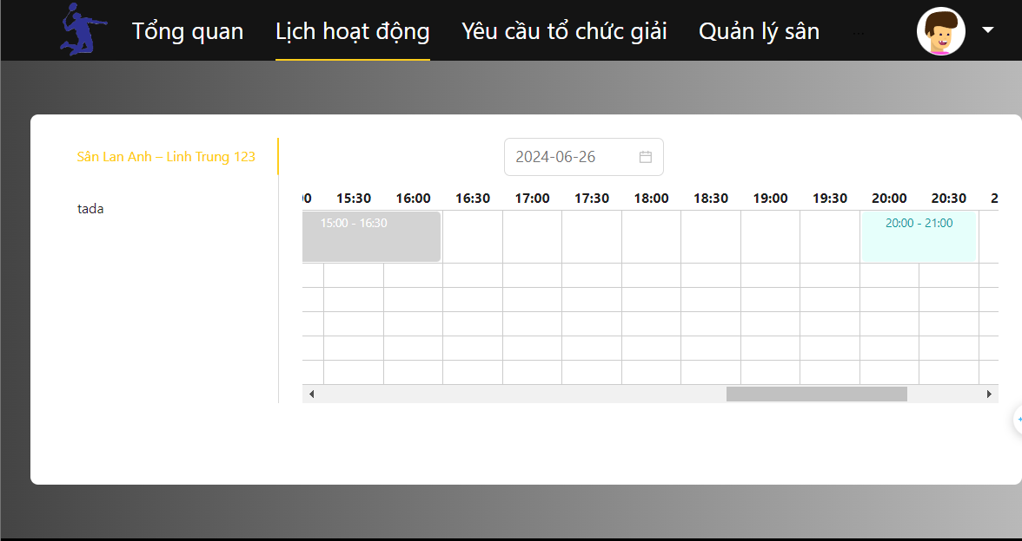

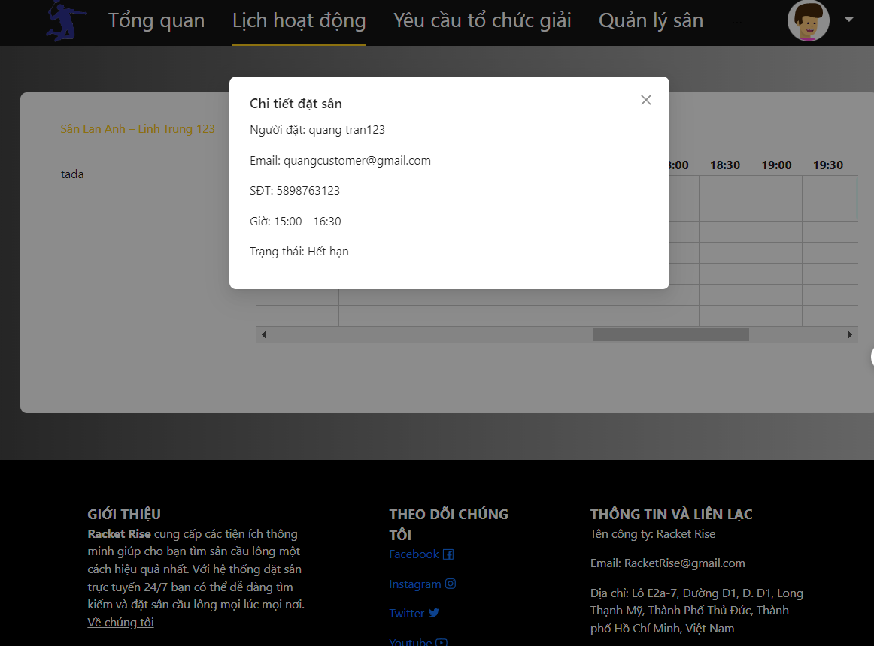 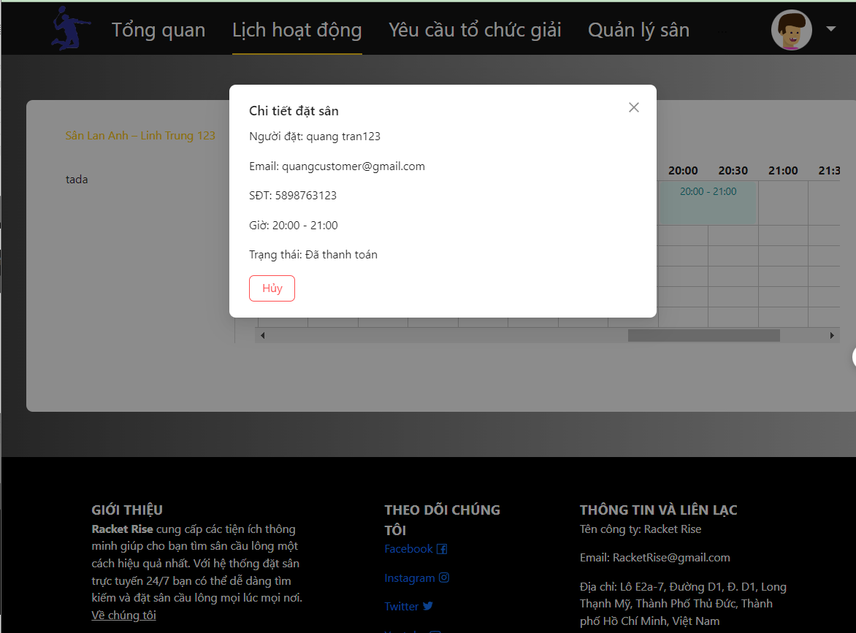

Function details:

* Pre-condition: Just Manager can check in booking.
* Flow:
  + Manager Select the booking marked on the court to see the booking detail
  + Manager click “Xác nhận” button when booking on time.
  + System change status booking to completed.
* Business Rules:
  + Only Manager can view Calendar.
  + Only when booking on time can the manager complete the booking.
  + If the booking has exceeded the end time and the customer has not yet checked in, the booking status will automatically change to expired.

3.3.13 Manage Center

*3.3.13.1 View List personal Center*

Function description: Manager can view a list of their Centers with corresponding statuses and uptime if the status is active.

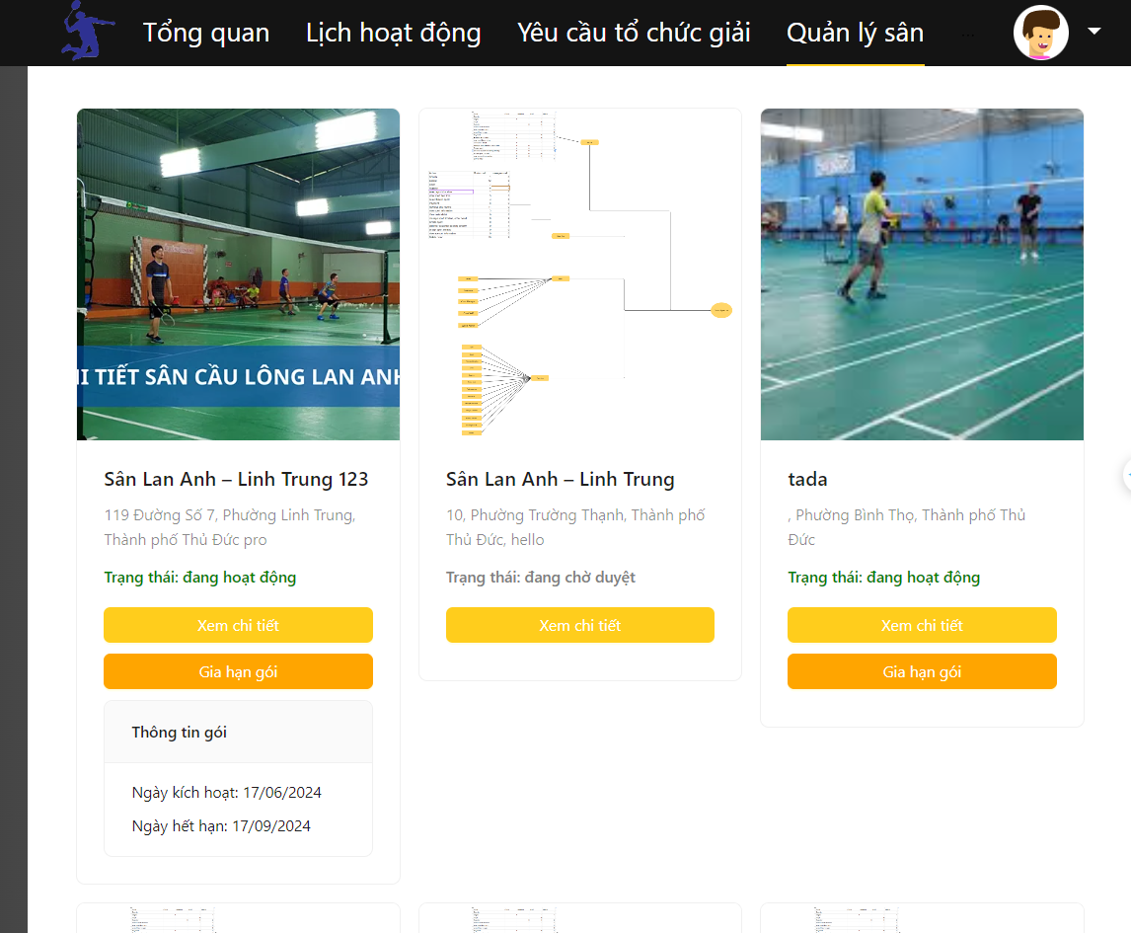

*3.3.13.2 View Personal center detail*

Function description: Managers can view detailed information about their Center.

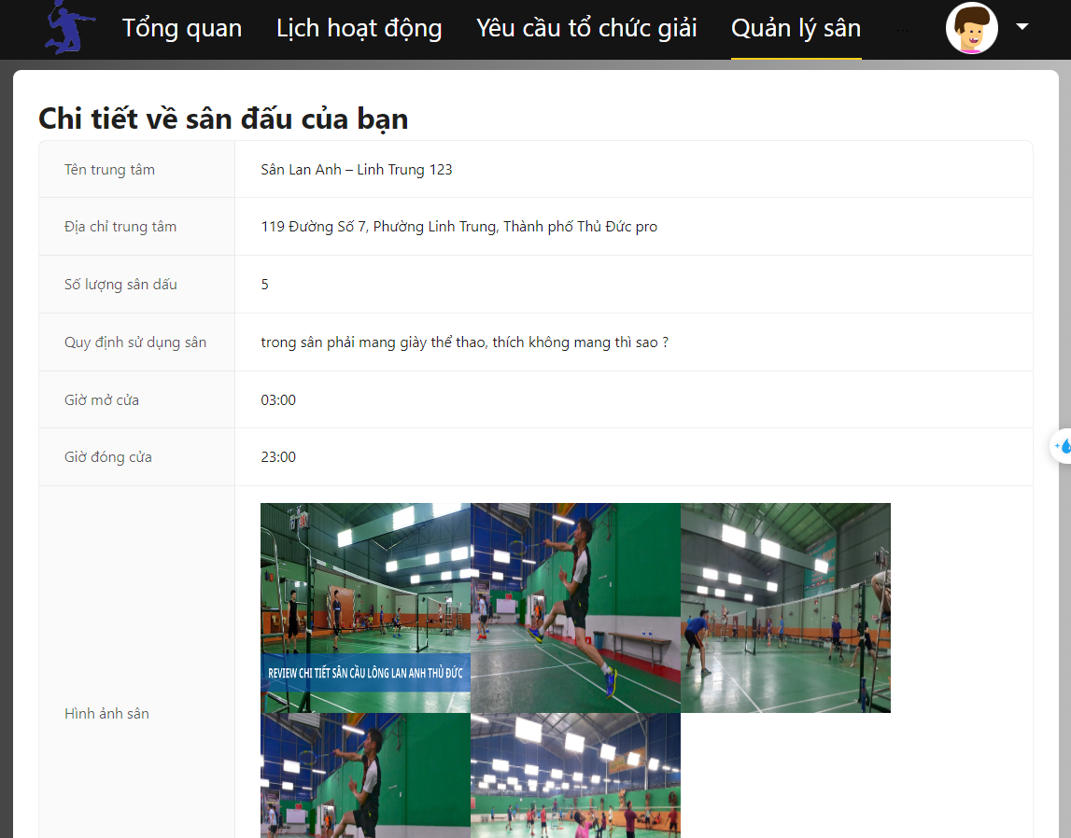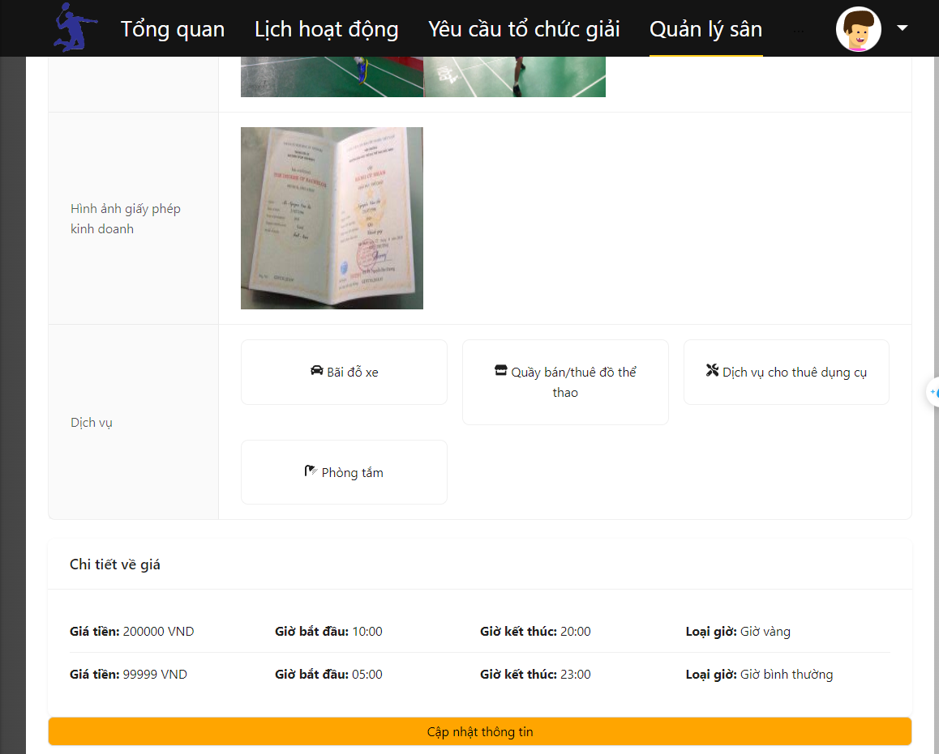

*3.3.13.3 Update Personal Center Information*

Function trigger: Fill in the required information and click the "Cập Nhật" button.

Function description: Managers can update their center information.

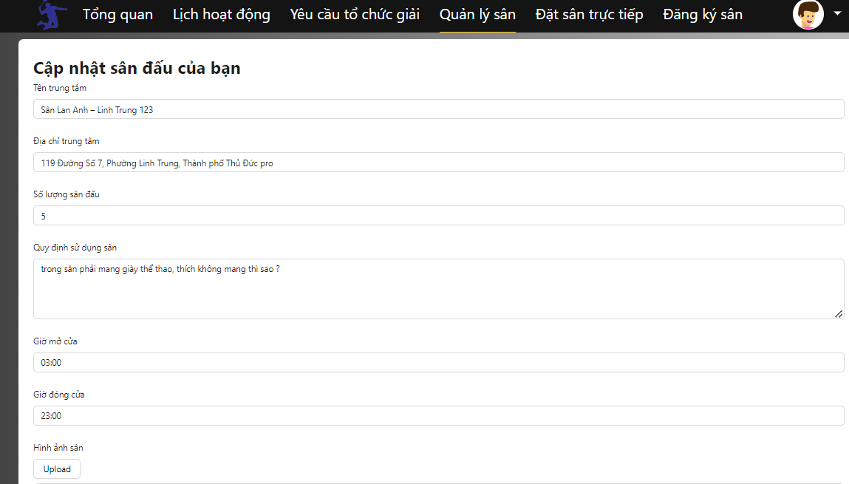

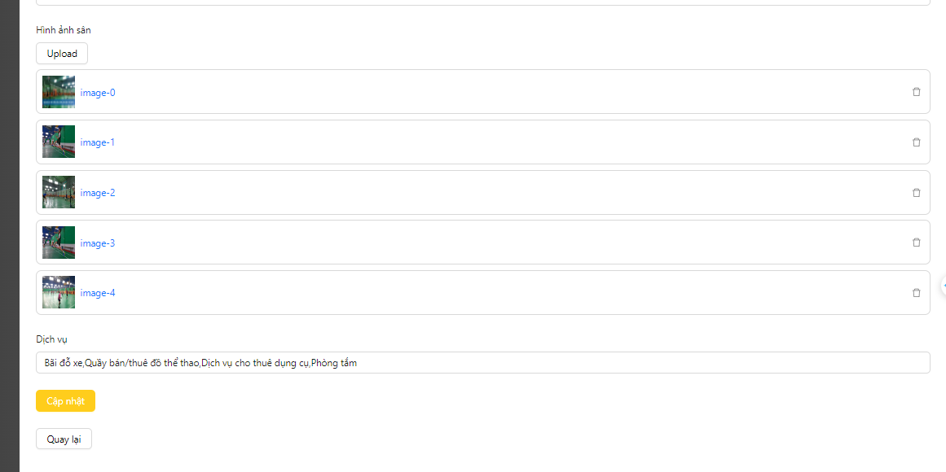

Function details:

* Pre-condition: Just Manager can Update their Center.
* Flow:
  + Manager changes the desired information
  + Manager click “Cập Nhật” button.
  + System change center Information.
* System validates Update:
  + Success: The system announces success and redirects users to Manager Center Detail page.
  + Fail: The system reports failure.
* Business Rules:
  + Only Manager can update their center information.
  + If the center has an active status, it will not be updated.

3.3.14 Booking Directly

*3.3.14.1 Booking Directly*

Function trigger: Manager fills in the customer's information and selects the playing time frame as requested by the customer and presses the "Confirm court reservation for customer" button..

Function description: The function allows managers to book courses directly for customers without the customer having to go to the platform.

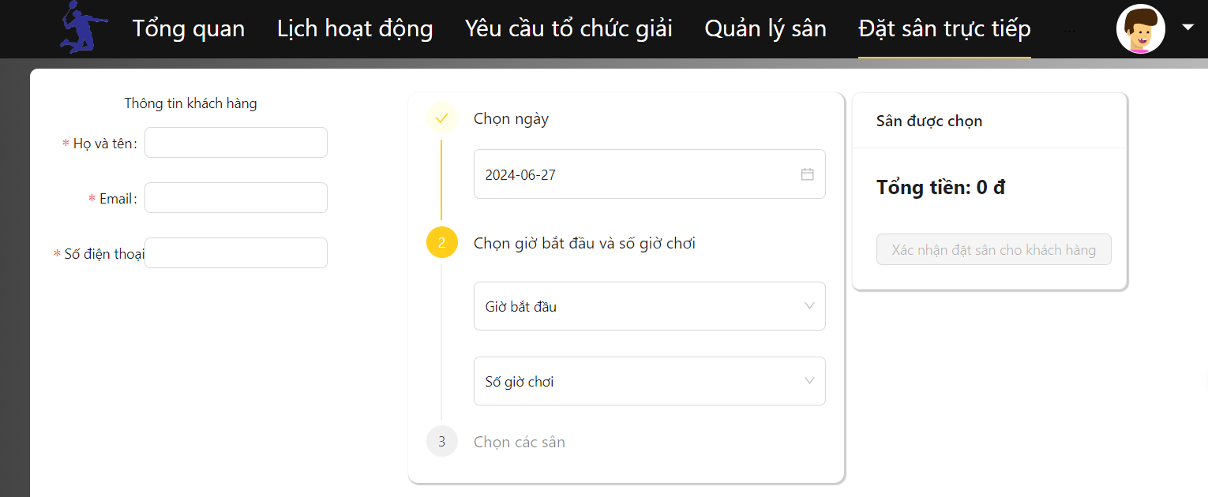

Function details:

* Pre-condition: Just Manager can Update their Center.
* Flow:
  + Manager changes the desired information
  + Manager click “Cập Nhật” button.
  + System change center Information.
* System validates Update:
  + Success: The system announces success and redirects users to Manager Center Detail page.
  + Fail: The system reports failure.
* Business Rules:
  + Only Manager can booking directly for customer.
  + If the customer's email is not in the system, the system will automatically create an account for the customer.

## 4. Non-Functional Requirements

### 4.1 External Interfaces

*[This section provides information to ensure that the system will communicate properly with users and with external hardware or software/system elements.]*

*4.1.1* User interface

* User interface must be user-friendly.
* *User interface must be responsive in order to fit on device screen desktop.*
* *Fonts, and colors must follow a theme structure and have meaning.*
* *Icons should be included to present the meaning of action.*

### 4.2 Quality Attributes

*[List all the required system characteristics (quality attributes) specification. Some of the possible attributes are provided with the guide/descriptions are mentioned here]*

#### 4.2.1 Usability

* Nice user interface and user-friendly. Colors, fonts, and icons should be in harmony, follow theme, and have meaning
* Dashboard features should be realistic and support administration works

*4.2.2 Security*

* Important input data are validated before saving to the database.
* User only able to access resources when having suitable permission, and role.

## 5. Requirement Appendix

*[Provide business rules, common requirements, or other extra requirements information here]*

### 5.1 Business Rules

*[Provide common business rules that you must follow. The information can be provided in the table format as the sample below]*

|  |  |
| --- | --- |
| ID | Rule Definition |
| BR-01 | Each time purchasing playing hours at a center, customers must purchase at least 10 hours. |
| BR-02 | Customers can only change or cancel a booking before the booking start time. |
| BR-03 | Managers can only confirm bookings within the start and end time of the booking. |
| BR-04 | When creating a center, managers must provide at least 2 photos of the business license. |
| BR-05 | Managers can only purchase operation packages for the center when the center has been approved by the admin. |
| BR-06 | When a center's information is updated, its status will revert to pending and await admin approval. |
| BR-07 | Admins must approve all new centers before they can operate on the system. |
| BR-08 | Customers are not allowed to book overlapping time slots for the same court. |
| BR-09 | If the old booking has a higher price than the new booking, when changing the booking, the Customer will not receive the difference |
| BR-10 | All payments must be processed through the system's integrated online payment system. |
| BR-11 | Managers have the right to check and adjust prices for each time slot based on different booking types. |
| BR-12 | Customers can purchase flexible hour packages and use them to book single or multiple sessions as desired within a month. |
| BR-13 | All passwords must be encrypted and protected with 256-bit encryption. |

### 5.2 Common Requirements

*[Fill all the common requirements here..]*

### 5.3 Application Messages List

|  |  |  |  |  |
| --- | --- | --- | --- | --- |
| **#** | **Message code** | **Message Type** | **Context** | **Content** |
| 1 | MSG01 | In line | There is not any search result | *No search results.* |
| 2 | MSG02 | In red, under the text box | Input-required fields are empty | *The * field is required.* |
| 3 | MSG03 | Toast message | Update account success | *Cập nhật tài khoản!* |
| 4 | MSG04 | Toast message | Update account error | *Có lỗi xảy ra khi cập nhật tài khoản.* |
| 5 | MSG05 | Toast message | Cancel booking success | *Hủy đặt sân thành công* |
| 6 | MSG06 | Toast message | Cancel booking error | *Hủy đặt sân thất bại* |
| 7 | MSG07 | Toast message | Update password succes | *Cập nhật mật khẩu thành công!.* |
| 8 | MSG08 | Toast message | Update password error. | *Có lỗi xảy ra khi cập nhật mật khẩu.* |
| 9 | MSG09 | Toast message | Upload image success when create or update Center | *Tải ảnh lên thành công* |
| 10 | MSG10 | Toast message | Upload image error when create or update Center | *Đăng tải ảnh không thành công, hãy kiểm tra lại tệp* |
| 11 | MSG11 | Toast message | Login Fail | *Email hoặc mật khẩu không đúng!* |

### 5.4 Other Requirements…